**END POINT MANAGEMENT AND IT ASSET INVENTORY MANAGEMENT SOFTWARE ( 8500 pieces )**

**IT ASSET INVENTORY MANGEMENT SYSTEM:**

Features 1 - Supports Auto –Discovery of Asset with ability to load discovered information to asset register/system., Provision for allocation/de-allocation of assets, Capable to perform hardware and software base lining, as well as illustrate the variance in attributes for both hardware and software assets through asset discovery, Capable to sync asset register/inventory with the IT Service Management CMDB(Configuration Management Database) both through automated approval, or through change management system and manual approval, Capable to execute scripts that are distributed from a centralized policy server on endpoints across locations through proxies located at various networks across the organization, Capable to perform policy based configuration compliance on all endpoints from a centralized location, Capable to integrate with Active Directory services, NA

IT Asset Auto-Discovery and Inventory Management:

The most important part of IT Asset Management (ITAM) is to be able to scan/discover all the assets in your network. Only when you have discovered all the assets can you efficiently monitor and manage them. At **DigitoWork** we use AssetExplorer that gives you a wide range of asset scanning methods to make sure that you get them all. Our key functions are:

* Centralizing asset repository
* Efficient tracking and record keeping
* Reduce the labor requirement for AIM-Asset Inventory Management
* Tracking assets throughout their lifecycle
* Discovering any possibility for threats or changes to the assets in advance

Through the use of this system, i.e. monitoring of assets, the evidence is provided to the organization that can be useful in making decisions ahead of time. This will help you to schedule regular maintenance of assets. This is because not only are the assets tracked but their age is also fully defined as to how much value they bring in to the organization.

For a robust inventory tracking system, **DigitoWork** is focus on:

* Evaluation of the business
* Defining the asset lifecycle
* Choosing the right IT AIM software
* Correct implementation
* Monitoring, reviewing and updating the system

### Asset Management

All the assets in the **DigitoWork-** network are broadly categorized in AssetExplorer as IT Assets, non-IT assets, asset components, software and groups.

### Product and vendor details

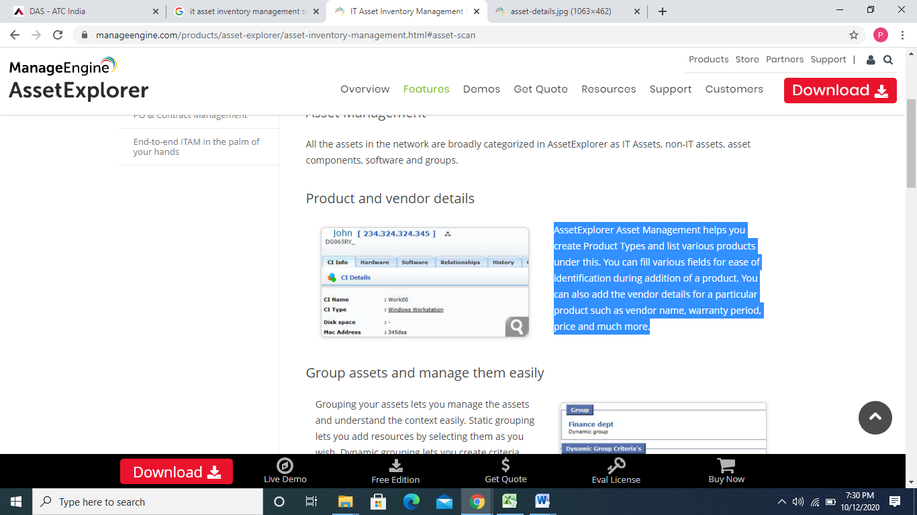

AssetExplorer Asset Management helps you create Product Types and list various products under this. You can fill various fields for ease of identification during addition of a product. You can also add the **DigitoWork** details for a particular product such as vendor name, warranty period, price and much more.

### Group assets and manage them easily

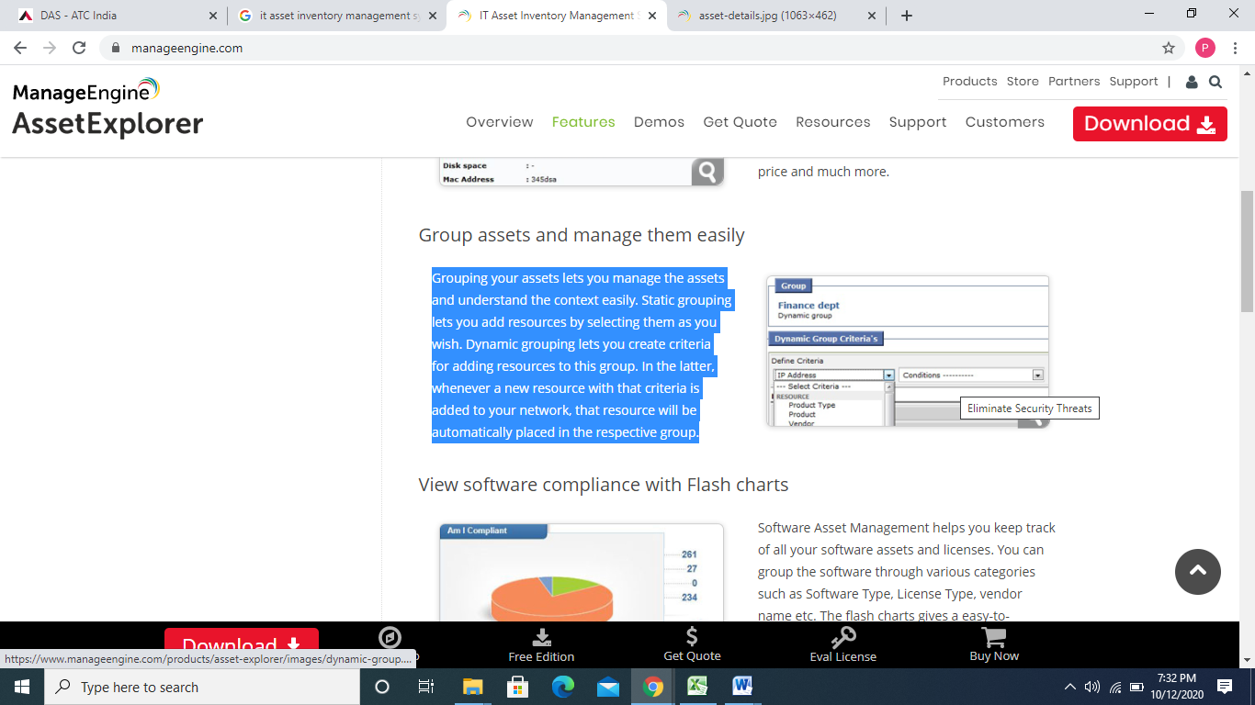

Grouping your assets lets you manage the assets and understand the context easily. Static grouping lets you add resources by selecting them as you wish. Dynamic grouping lets you create criteria for adding resources to this group. In the latter, whenever a new resource with those criteria is added to your network, that resource will be automatically placed in the respective group.

### View software compliance with Dashlet charts

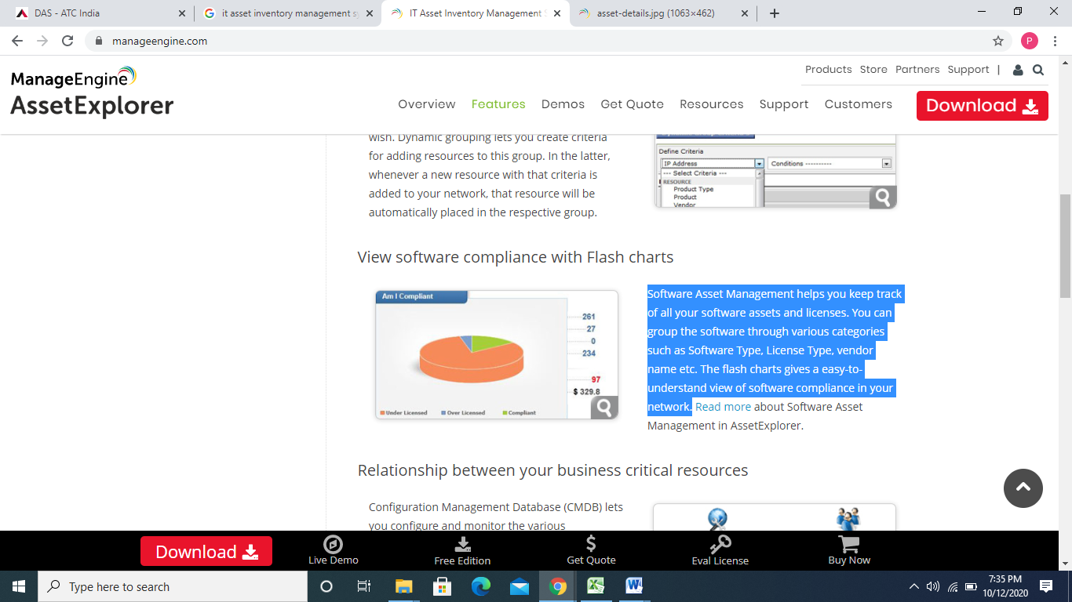

Software Asset Management helps you keep track of all your software assets and licenses. You can group the software through various categories such as Software Type, License Type, vendor name etc. The flash charts give an easy-to-understand view of software compliance in your network.

### Relationship between your business critical resources

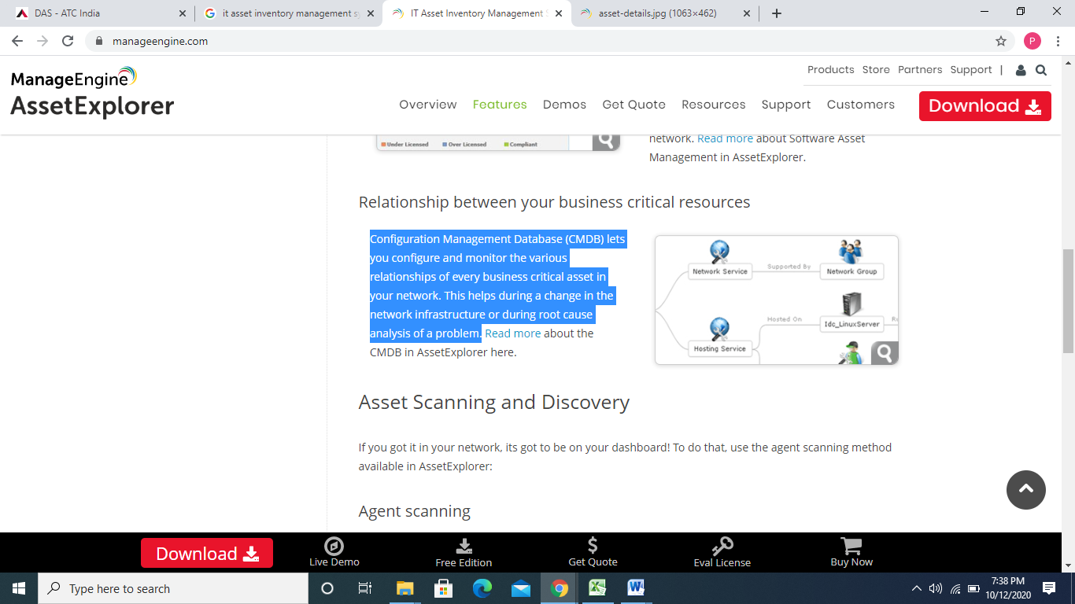

Configuration Management Database (CMDB) lets you configure and monitor the various relationships of every business critical asset in your network. This helps during a change in the network infrastructure or during root cause analysis of a problem.

Asset Scanning and Discovery

If you got it in your network, it’s got to be on your dashboard! To do that, use the agent scanning method available in AssetExplorer:

* Agent scanning

In this method, an agent is installed in the workstation (in the same network or remote location) to be scanned. The first time, agent sends all information about the asset inventory to the AssetExplorer, after which it will send only the changes in the inventory.

* More scanning methods:
* **Windows domain scans**

Any assets coming under the Windows domain can be scanned using this method.

* **Network and network range scans**

This method of asset scanning can be used for all IP devices, such as, routers, switches, printers and assets running Linux, Solaris and MAC OS. Enter the Network or the network range and AssetExplorer takes care of rounding up the assets to the dashboard.

* **Individual asset scan**

You can also scan the assets individually by providing the IP address of the asset.

* **Manual import**

When all else fails or if you have a csv file of all your assets and want to import that file, you can just import the file and add all the assets to AssetExplorer.

**DigitoWork – Our Functions**

**IT Asset Auto-Discovery and Inventory Management**

1. Discovery works without requiring agent installation (that is, agent-less discovery) while discovery Layers 2 through Layers 7 of OSI model,

2 .Uses Industry- standard protocols such as WMI, SNMP, JMX, SSH to perform discovery without requiring the installation of an agent,

3. Discovery system has ability to modify out-of-box discovery scripts, create customized discovery scripts,

4. Discovery system has the ability to capture configuration files for the purposes of comparison and change tracking,

5. Discovery system be capable of supporting role- based access to various aspects of CMDB administration,

6. Discovery be object-oriented, allowing specific CIs and relationships to be discovered using a library of discovery patterns,

7. Discovery engine gathers detailed asset and configuration item (CI) information for specific servers and the applications running on them,

8. It dynamically discovers and continuously map IT hardware inventory and service dependencies,

9. The EMS provides a common configuration management database that has a single solution for discovery of networks devices, servers & desktops, using a common probe, that supports both agent less and agent based technologies using.,

10. Inventory management of each of the equipment to be available 24X7.

**Configuration Management Database** (CMDB) is a centralized repository that stores information on all the significant entities in your IT environment. The entities, termed as **Configuration Items** (CIs) can be hardware, the installed software applications, documents, business services and also the people that are part of your IT system. Unlike the asset database that comprises of a bunch of assets, the CMDB is designed to support a vast IT structure where the interrelations between the CIs are maintained and supported successfully.

## Configuration Item Types (CI Types)

## 

The CIs within the CMDB are categorized into specific **Configuration Item Types** (CI Types). Each CI Type is represented with **Attributes** and **Relationships** that is unique for the CIs classified under it. Attributes are data elements that describe the characteristics of CIs under the CI Type. For instance, the attributes for CI Type Server can be Model, Service Tag, and Processor Name and so on. Relationships, on the other hand, denote the link between two CIs that identifies the dependency or connection between them.

A CI Type can form a hierarchical structure by further drilling down to **Sub Types**. Each Sub Type inherits the Attributes and Relationships from the parent CI Type.

## Relationship Map

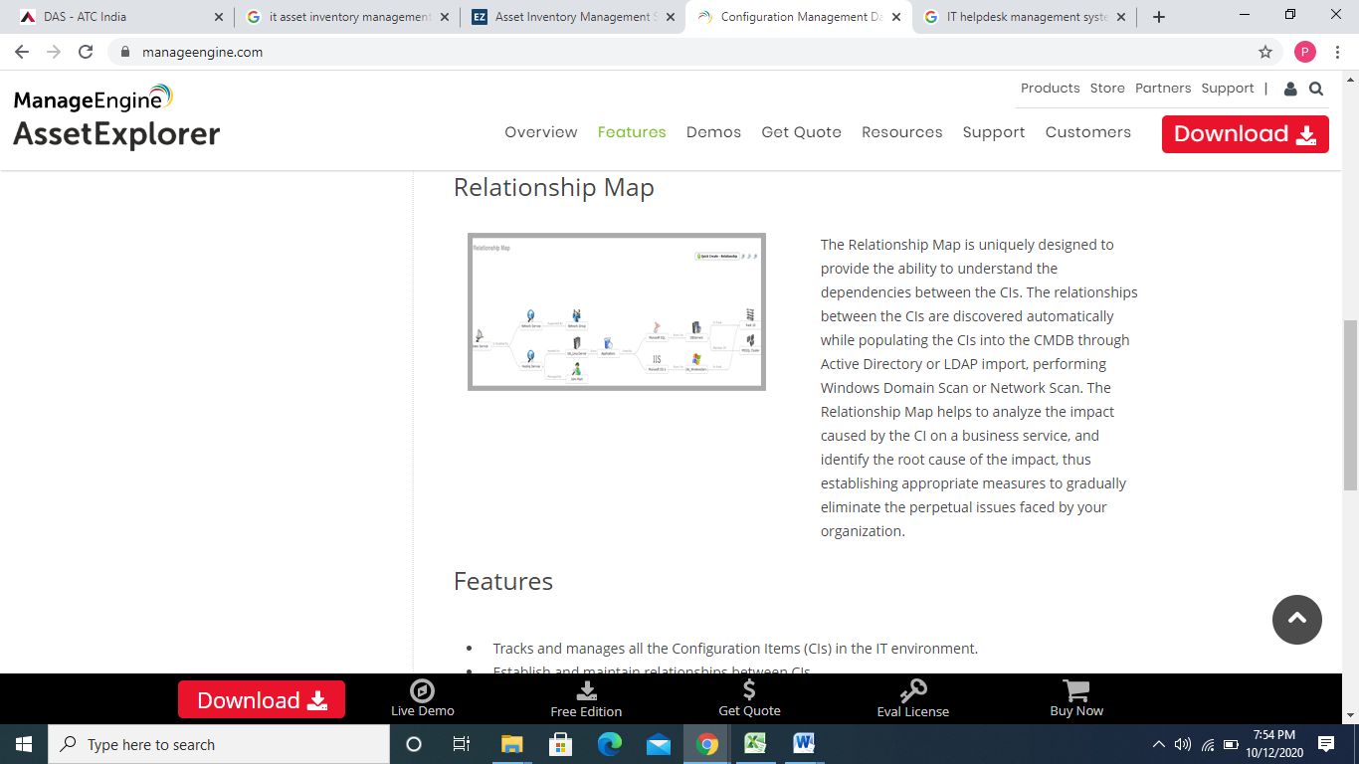

The Relationship Map is uniquely designed to provide the ability to understand the dependencies between the CIs. The relationships between the CIs are discovered automatically while populating the CIs into the CMDB through Active Directory or LDAP import, performing Windows Domain Scan or Network Scan. The Relationship Map helps to analyze the impact caused by the CI on a business service, and identify the root cause of the impact, thus establishing appropriate measures to gradually eliminate the perpetual issues faced by your organization.

**Features**

* Tracks and manages all the Configuration Items (CIs) in the IT environment.
* Establish and maintain relationships between CIs.
* Ability to add default Attributes and Relationships to a CI Type.

**Benefits**

* Track all your CIs and their details in a centralized repository – The CMDB.
* With the help of the relationship map, the impact caused by a CI on other CIs, the root cause of the impact can be identified and appropriate measures can be established to eliminate the issue.

**DigitoWork** – Key Functions

1. Provides a single shared view of services supporting Service Design, Transition and Operations stages of the lifecycle,

2. The Configuration Management Database supports multiple datasets with federation and reconciliation facilities so as to get data from various discovery tools and also through manual import process,

3. Reconciliation of data is possible with multiple data providers based on common attributes and ability to define precedence rules on attributes,

4. Federation of external data sources be possible with ability to store common attributes inside CMDB and getting other attributes from external data sources,

5. Automatically create Service models to describe how IT infrastructure supports business services,

6.The CMDB has built-in drift management capabilities to capture and report on infrastructure drift based on infrastructure attributes like RAM, memory, etc.,

7. System with CMDB - Integrate people, process & technology. To help in reducing likelihood of downtime by facilitating communication across all the facility equipment while Managing SLAs and Asset Lifecycle with IMAC process.,

8. Configuration item to get automatically attached with the ticket to enable maintenance team for faster resolution.

Features 2 - Client server architecture with central management * 4 / 11 and capable to cover end points across locations and subnets, Provide an easy-to access, user interface to submit, view updates and search solutions, Track/discover all asset deployment, hardware/Software inventory, their lifecycle information using single console/system, Capability of deploying agent through active Directory GPO, scripts, manual download and installation by administrators, Provides the availability of Remote Desktop connection (RDP) from the tool to Desktops /Laptops/Servers over the LAN/WAN/ Internet, Provision for multiple Assets to be imported or exported in one go, NA

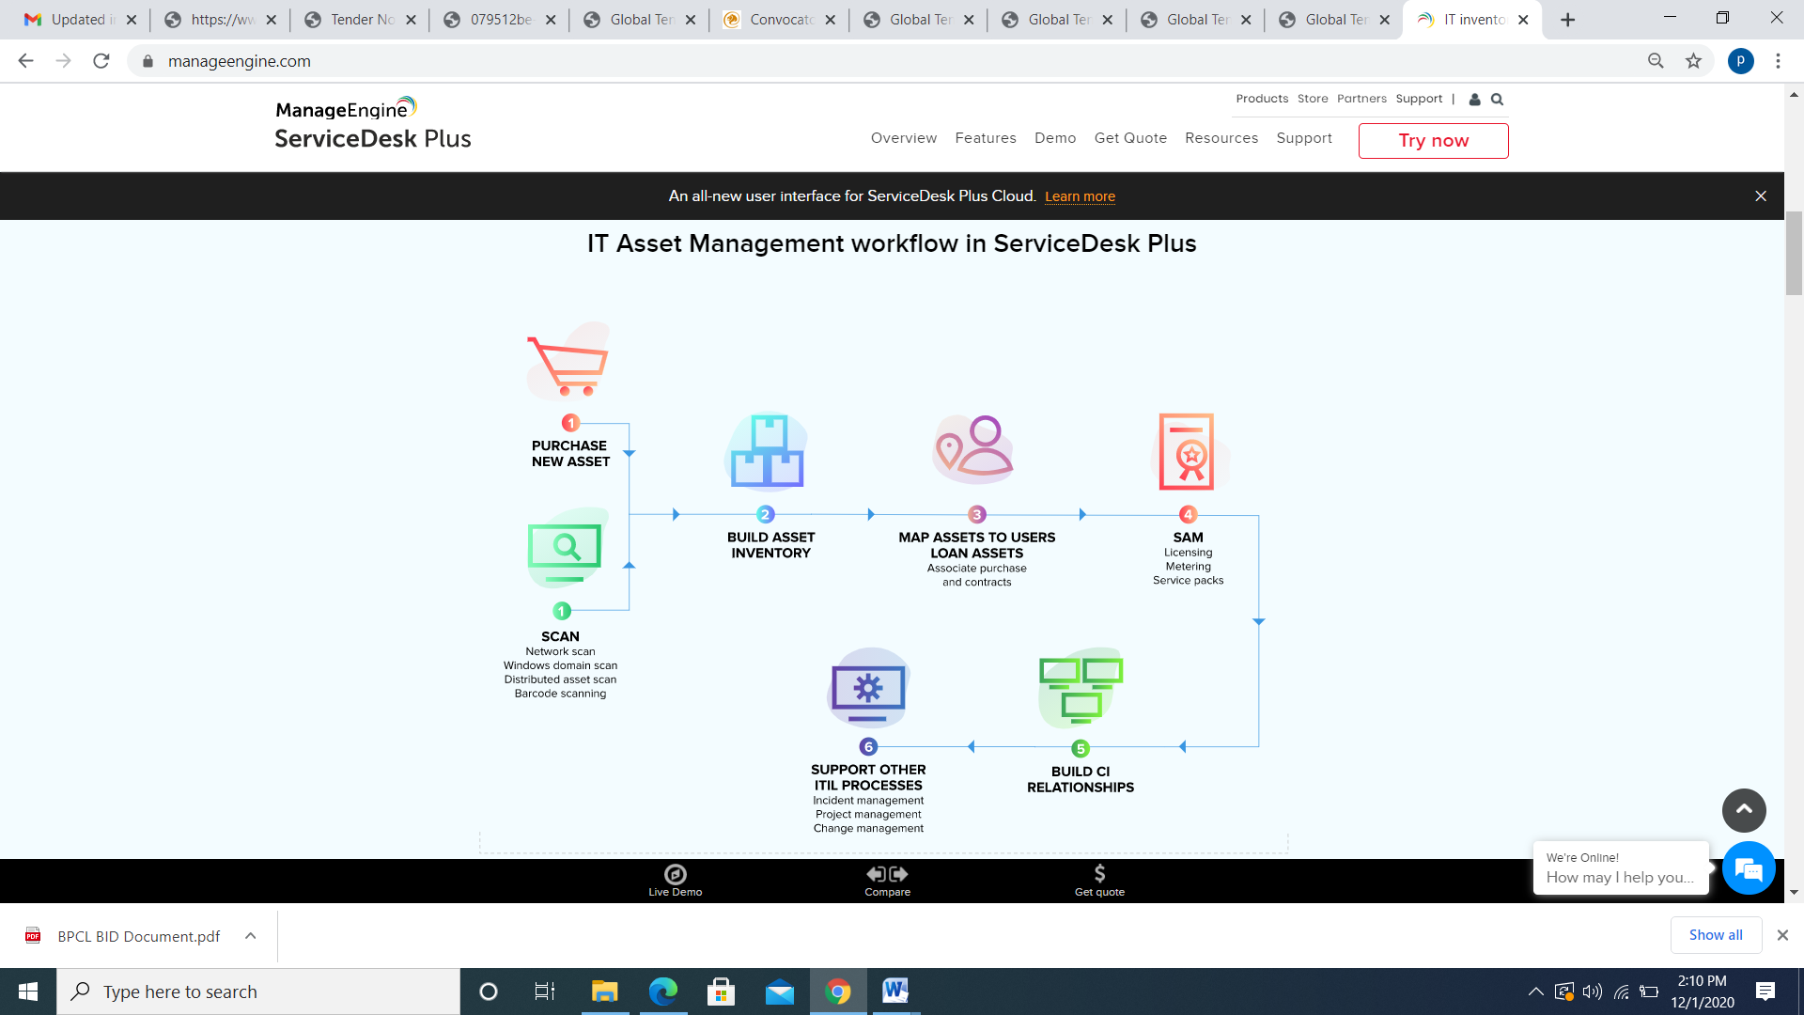

Discover, Manage, and Track All Your Hardware Assets.

* + Scan all your Windows devices, non-Window devices, VMs, and network devices through simple asset scanning techniques.
  + Get comprehensive asset information like hardware specification, software installed; scan history, asset ownership history, and asset states in a single pane of glass.

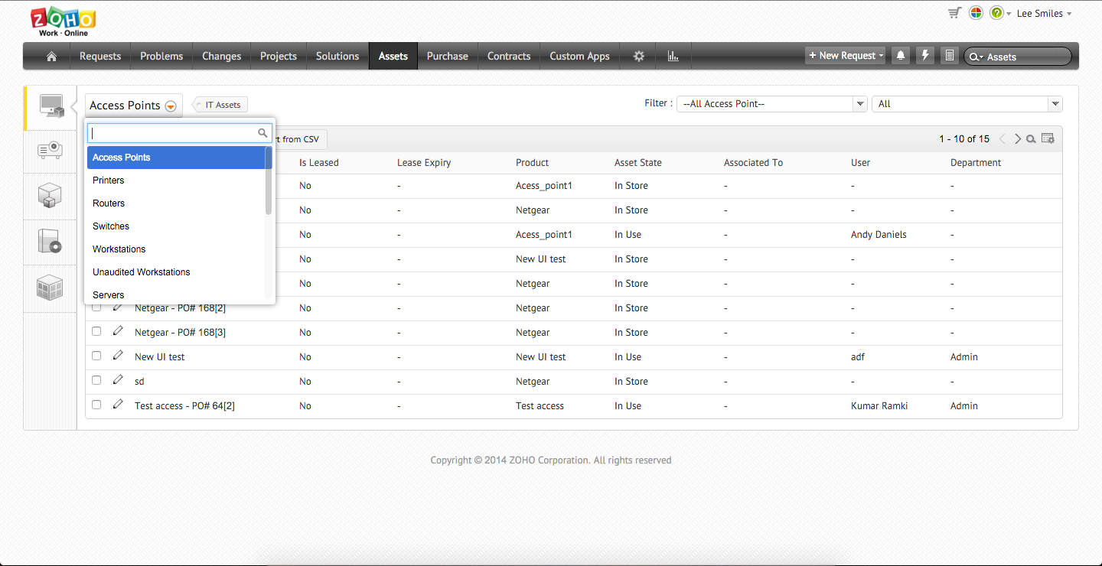

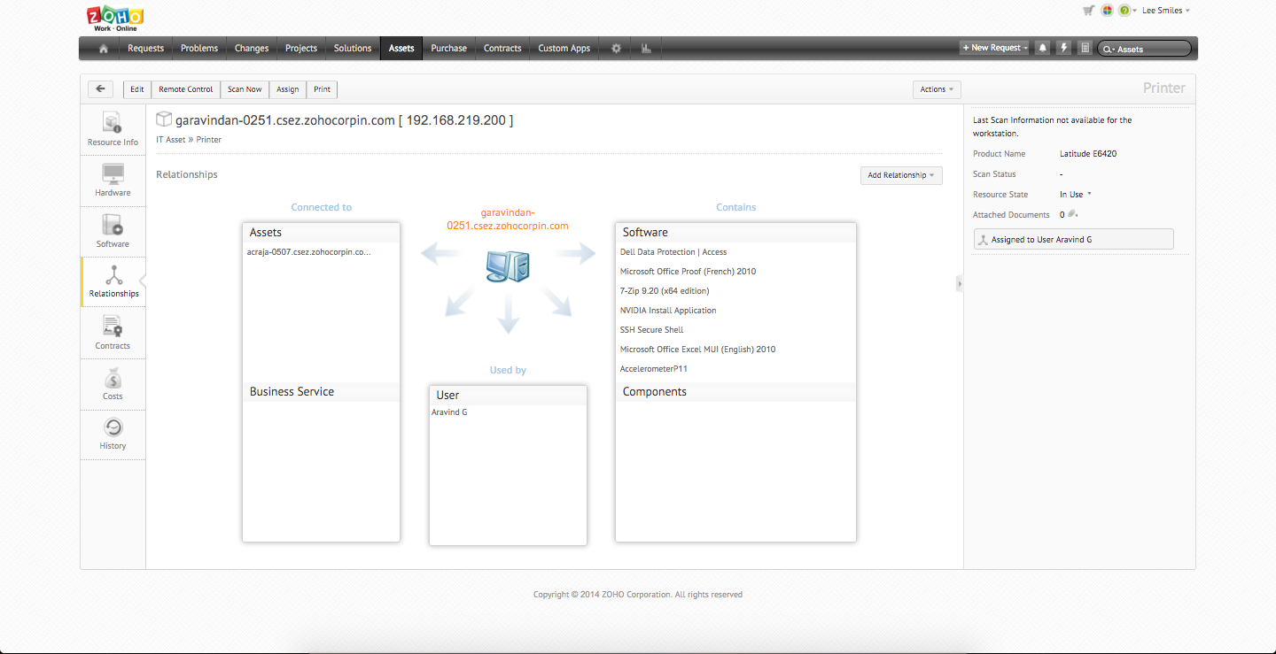

### Map Asset Relationships with CMDB. Understand you’re IT Environment Better.

* + Create a high level of synergy by building relationships between people, assets, and other Configuration Items (CI).
  + Use pre-defined and custom relationship types to get a visual view of asset relationships.
  + Enable an effective problem management and change management planning by building a logical model of your IT infrastructure in the CMDB.

### Manage Software and Ensure Compliance. Sail Through Audits Easily

* + Improve software governance by monitoring software usage (unused, rarely used, and so on), number of installations, license types, compliance status, and license expiration.
  + Isolate vulnerabilities like malware and unauthorized or prohibited software to reduce potential risks.
  + Manage software licenses for every software installation on every workstation across the enterprise.
  + Track over licensed, under licensed and compliant software to ensure software license compliance.
  + Sail through software audits easily by tracking every installation and allocating individual software licenses across installations.

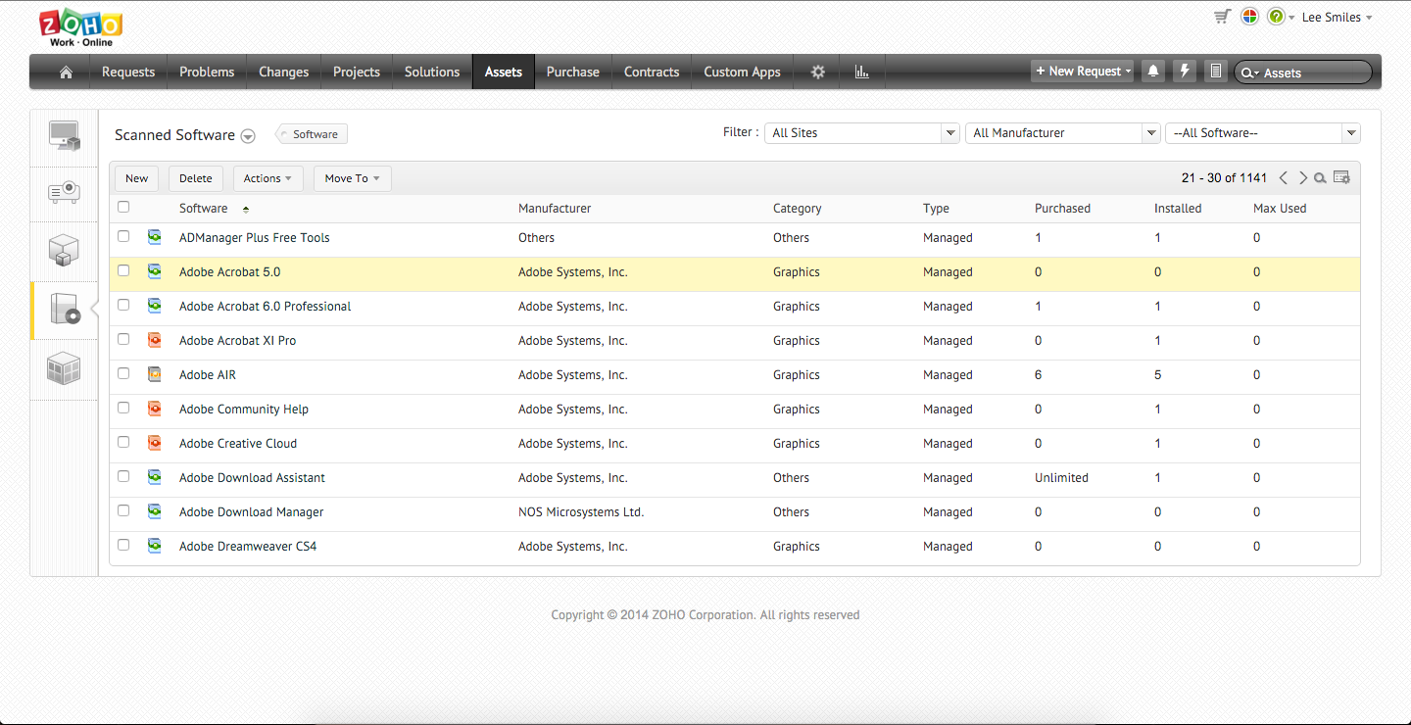

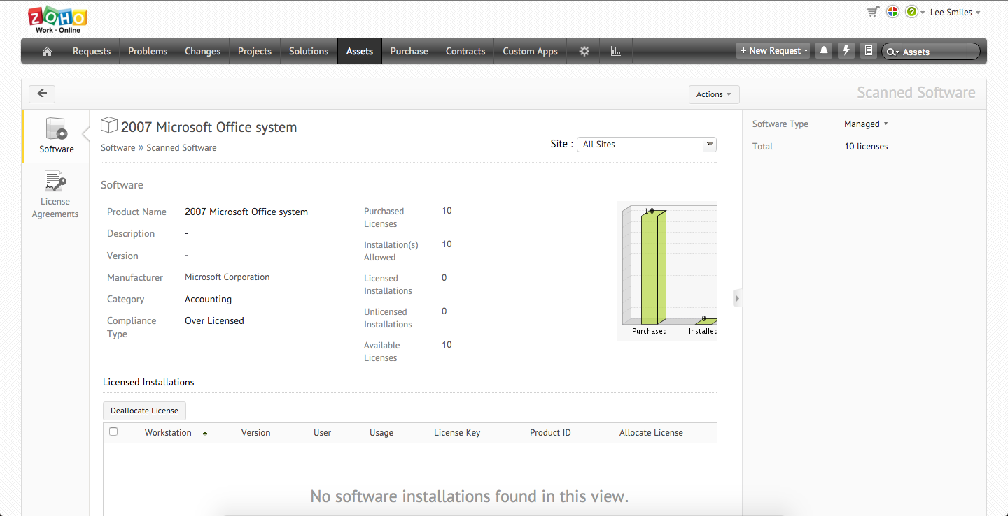

### Track IT Asset Purchases and Contracts. Manage IT Budgets Better.

* + Manage the complete life cycle of purchase orders with a structured approval and delivery process.
  + Maintain a complete product catalog of all assets owned by the company with price and warranty details.
  + Maintain a vendor catalog, compare prices from different vendors, and analyze purchase trends to leverage negotiations.
  + Keep track of IT contracts and get notified about their expiry in advance.

As your IT infrastructure adds more IT assets, it is hard to manually add new ones and update any changes in the old ones. Be it the software installed/upgraded or a hardware change. A simple hardware change, when tried to update manually, can become a very challenging task, this is when IT asset tracking becomes critical. **DigitoWork** AssetExplorer helps you in tracking your hardware and software automatically. It not only automatically scans and discovers your IT assets but also updates every time there is a change in any of the IT assets.

**DigitoWork** AssetExplorer helps you with:

1. Hardware inventory tracking
2. Software inventory tracking
3. Associated vendors and contracts
4. Managing asset groups
5. Asset relationship
6. Asset history

### Software and Hardware inventory tracking

[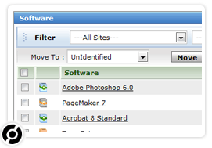](https://www.manageengine.com/products/asset-explorer/images/software-hardware-view.jpg)

Track all the IT assets - software and hardware - in your IT infrastructure. The hardware that can be identified with **DigitoWork** AssetExplorer are workstations, printers, routers, switches & any devices with an IP address and connected to the network and some of the OS that are discovered - Windows, Linux, Solaris, Mac, IBM AIX and VMWare ESX/ESXi. The software inventory is also scanned across the network devices and listed in AssetExplorer. The dashboard has easy-to-understand charts that gives you the inventory detail at a glance.

### Scan, Discover & Update - Automatically

Any mundane task automated is a blessing. As an asset manager, it would be great for you to have a tool that automatically scans you network, discovers IT assets (hardware and software) and updates whenever there is a change in any of IT assets. **DigitoWork** AssetExplorer has a number of ways to perform those tasks. Read more on Asset scanning methods.

### Tracking Ownership, Status & Total Cost of Assets

[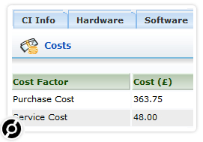](https://www.manageengine.com/products/asset-explorer/images/tracking-ownership.jpg)

Get clear picture of the assets you own, the ownership details and its history. AssetExplorer accurately maintains a history of the asset that includes ownership history and changes during the asset's lifecycle. The support and maintenance costs incurred by the asset helps you understand the real cost of the asset - Total Cost of Ownership. This helps in forecasting and making purchase decisions.

### Manage Contracts and License Agreements

[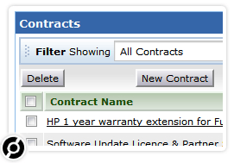](https://www.manageengine.com/products/asset-explorer/images/manage-contracts.jpg)

The tracking of IT assets gives you details on the contracts, software licenses and vendors associated with that particular asset. You can also enable notifications to specific users before the contract or license agreement period of the asset expires, thus making sure that you do not forget to renew your contracts.

### Group Assets for better and easier understanding

[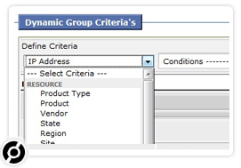](https://www.manageengine.com/products/asset-explorer/images/group-assets.jpg)

AssetExplorer helps you create focused asset groups for better management and control. You can create Static or dynamic groups based on asset properties and for ease of management. With static groups you can choose assets with different properties. Dynamic groups help you to group asset based on specific criteria. Tracking IT assets as a group gives you a better understanding of a group behaviour, be it department/geography/asset type wise.

### Asset Relationships - CMDB

[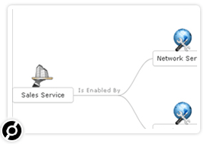](https://www.manageengine.com/products/asset-explorer/images/asset-relationships-cmdb.jpg)

Establishing relationships with other assets is a useful value adds to simply tracking IT assets. CMDB gives you a good understanding of the various relationship of an asset in your IT infrastructure. This helps when you are troubleshooting an incident or a problem. Knowing the relationships is the key to carrying out root cause analysis for a problem and rectifying it efficiently and quickly.

Features 3 - Provision for Remote Uninstallation from console/variance screen, Provision to disable un-used assets and maintain records of their entire service history for inventory, Provision for Creation of Multiple hierarchy of Stores or Branches or Regional offices/Head office., Provision for Gate pass creation and approvals for asset movement between stores/floors and Repair center

Internal control for inventory is especially important so we protect against theft and waste.

An effective **internal control structure**for inventory includes a company’s plan of organization and all the procedures and actions it takes to:

* Hierarchy of organization
* Location and internal location definition as a multiple hierarchy
* Stockroom definition and roll up
* Maintain asset audit-trail
* Evaluate the performance of all personnel to promote efficient operations.
* Ensure accurate and reliable operating data and accounting reports.

Asset reconciliation mode - Automatic means

# SAM Foundation software reconciliation for compliance

Automated license reconciliation keeps license positions accurate and up to date without manual calculations. Reconciliation runs weekly or on demand.

Reconciliation is a scheduled job that is run at a specified frequency (default is weekly). It can also be run on demand for specific or all publishers.

When reconciliation is run, a list of reconciliation results is created that shows the compliance status of software products with respect to discovery and entitlements. Users with the sam_user role can view reconciliation results.

## Software product results

You can access Software Models and Unlicensed Installs related lists from a product result record.

A product result for a licensable product is generated after reconciliation even if there are no software models defined for the product.

Allocation policy supported by the offered product - Asset allocation to single user

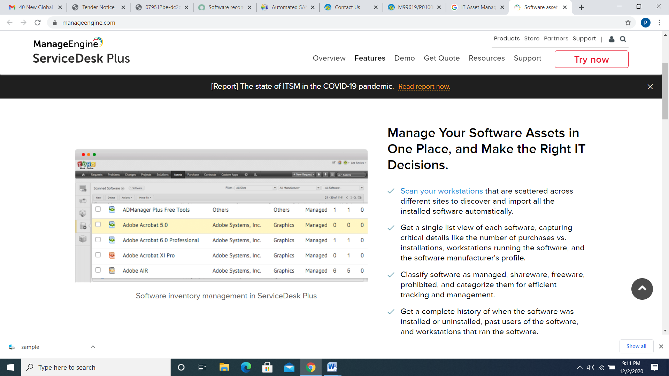

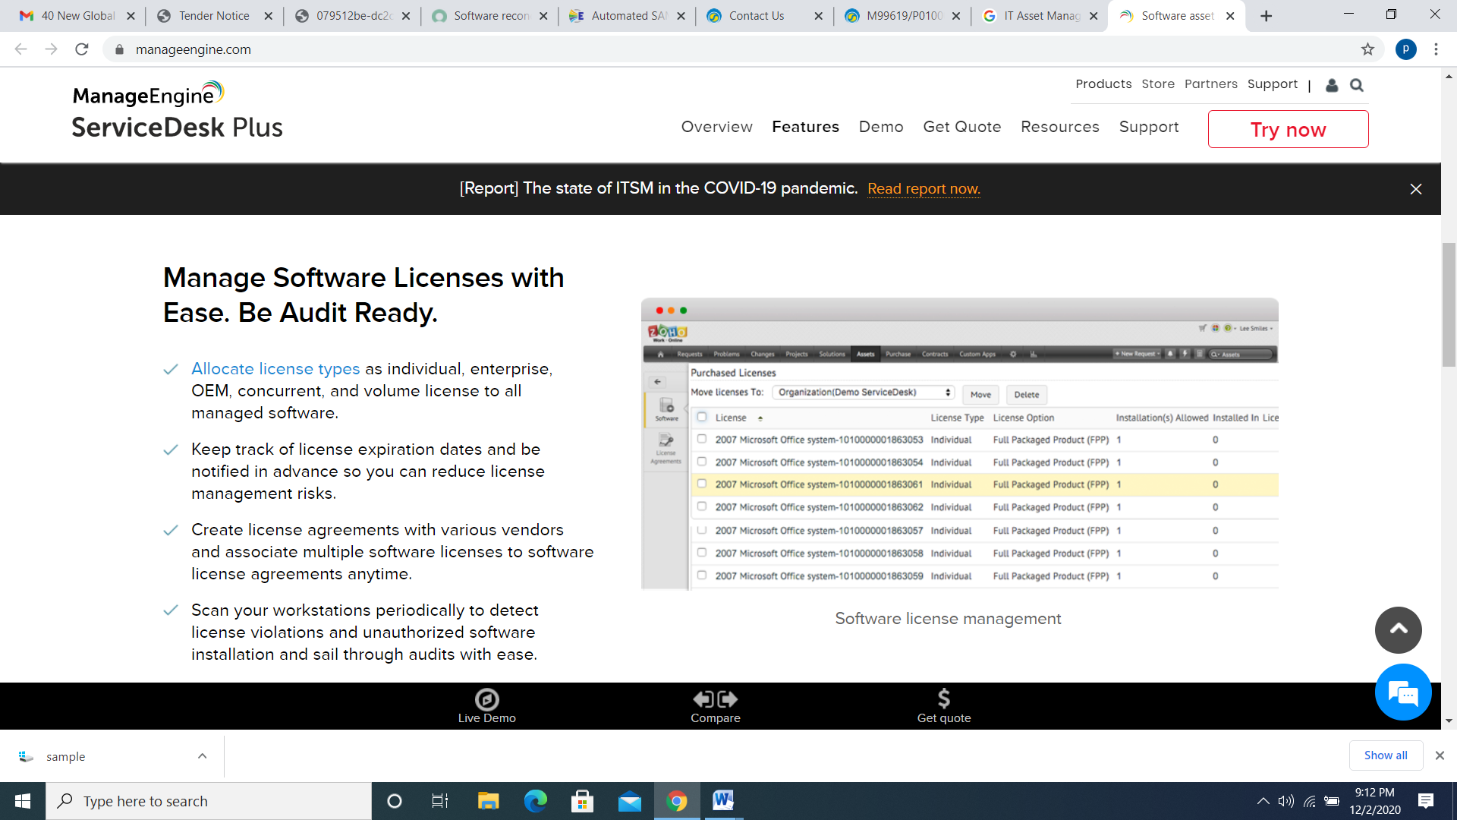

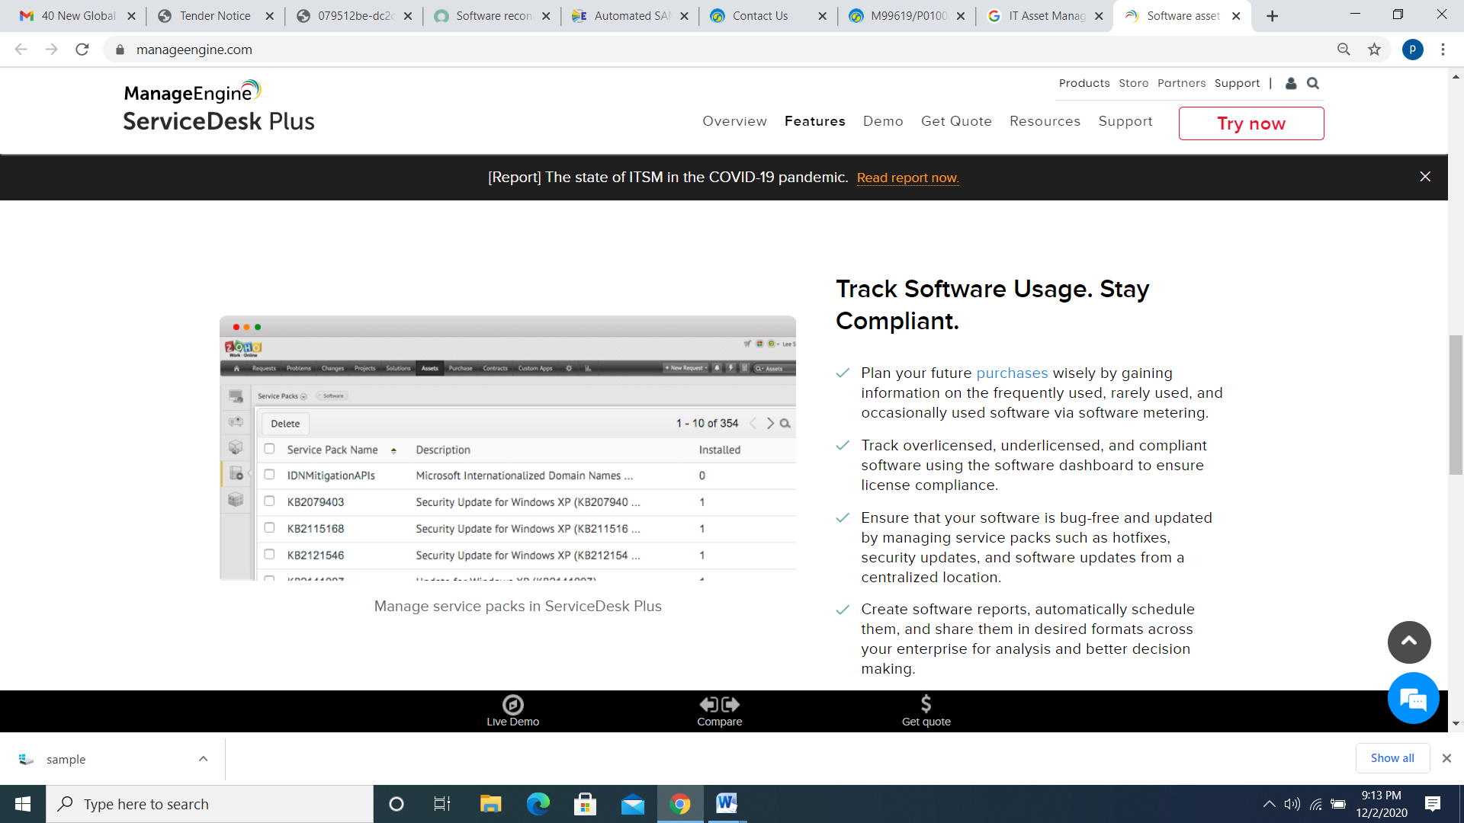

END POINT MANAGEMENT - End point management Features 1 -Capable to perform software installation on endpoints based on policy based approval., Capable to perform Patch Management and patch update distribution across offered asset base, Support Patches for Windows,Mac,Linux and 3rd party applications, Ability to enable/ disable automatic updates of patches available in enterprise computers, Provision for Software delivery management for MSI Packages and .exe, Provide Software license management capable of managing software assets and licenses, with a single solution for discovering software on the network, recording and validating license entitlements, and creating a dynamic best-fit reconciliation, Provision for Software license Reconciliation for software license compliance, Provision for Software compliance monitoring to understand the software license compliance and use of unauthorized software in the organization and generates reports, tracks all under-licensed, over licensed and compliant software., Capable to keep up-to-date software information and helps in saving time during software audit process, Provision for application control capability to Whitelist and Blacklist software or applications and capable to control the usage of unauthorized application. End users can not install/Execute any software, both ‘on’ and ‘off’ the network. (Even if the end user had local admin rights) unless it is whitelisted by the Software Administrator, Provision for Profile Base lining of Software by Asset, Department, Location, IP address.

## Asset management feature checklist

* **Inventory scanning**

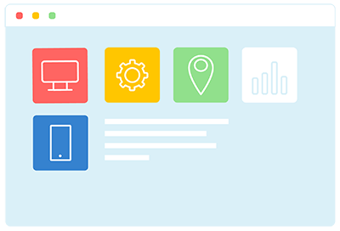

* Software asset management
* Asset life cycle
* Asset loaning
* Asset reports & Dashboards
* CMDB

**Discovery techniques for windows:**

* + Agent based scan
  + Agent-less scan. (Domain and network scan)

Discovery techniques (Macs, Linux, Printer, Unix, VMware and other network devices)

* + Network and credentials.
  + Probe scanning (Distributed asset scan)
  + Bar code scanning.

###### SOFTWARE AND HARDWARE INVENTORY OPTIONS INVOLVING SCCM

The **DigitoWork** provides two different discovery-oriented integration options around SCCM.

The first integration option uses the **DigitoWork** service to analyze raw inventory data collected by SCCM. This method processes hardware and software inventory information collected by the Microsoft SCCM agent, with no additional agent or end-process deployment required. The raw data is processed using **DigitoWork**’s extensive SCANMAN™ software and hardware knowledgebase to provide highly accurate, normalized and categorized data. This enriched data is particularly useful in support of Software Asset Management (SAM) programs and license reconciliation and optimization efforts. The end result is a level of comprehensive inventory reporting that supplements what SCCM could provide independently. With this approach, customers can realize additional value from their investment in SCCM to increase transparency and reduce risk around their enterprise network assets.

***SCCM Add-On Process***

The second integration option involves utilizing a version of the **DigitoWork** ITMC Discovery end-point analyzer as an add-on process that is managed by SCCM either in executable form or as a command to a share. This method does not require the installation of an extra agent service or executable on the target machine.

###### SCCM DEPLOYMENT INTEGRATION FEATURES

***Deployment Target Definition***

With seamless and secure API-based integration, ITMC Discovery can play a significant role in software deployments that are executed using SCCM. From an administration screen, a user can see a list of SCCM Defined Applications (packages that can be deployed) as well as SCCM Collections (pre-defined groups of machines to which software and updates can be deployed).  
Users can also view the details of the selected package/application to be deployed, including: Source Site, Sedo Object Version, Number of Deployments, Number of Devices with Application, Number of Devices with Failure, and Number of Users with Request. This data comes directly from SCCM.

Since users can select the existing SCCM Defined Applications and they can populate their own collections with target machines for deployment, **DigitoWork** now provides the ability for an ITMC Discovery user to complete the entire process end-to-end without requiring the involvement of an SCCM administrator outside of the creation of the packages/applications to be deployed.

***Deployment Verification***

ITMC Discovery can also take full advantage of the SCCM infrastructure to independently verify that Application deployments were successful. ITMC Discovery can perform this function by independently verifying the successful installation of an application.

**Automated Request – Approval – Provisioning**

In tandem with SCCM, **DigitoWork**’s ITMC Lifecycle and AppStore Plus Portal can support an automated request-approval-provisioning process. Authorized people throughout an organization may:

* Create a scheduled request for software to be deployed from a managed catalog
* Receive approval(s) to ensure enforcement of current processes
* Initiate purchases via contracts or purchase orders, or based on existing inventory
* View and claim available licenses, and
* Have software automatically deployed via SCCM.

This automation is achieved by enabling SCCM deployment application/package information to be imported into the **DigitoWork** system, where it can be assigned to the appropriate software catalog items to be used within the AppStore Plus Portal. Users may also assign multiple SCCM application/packages to a single catalog item to be deployed upon approval and designate which item should be the default.

***Automated License Harvesting***

**DigitoWork**’s Application Utilization Monitoring enables customers to set thresholds that reflect their definition of usage parameters for individual products. Installations that do not meet these criteria (considered to be unused or under-utilized) can be shared with SCCM for automated de-installation and license harvesting, enabling re-deployment to another person or machine.

###### BENEFITS

When the ITMC modules are integrated with SCCM integration, customers achieve:

* Enhanced data volume and quality, maintaining the use of SCCM for discovery while taking advantage of the SCANMAN software and hardware knowledgebase and normalization engine
* Secure, out of the box integration with SCCM collection and deployment
* Independent verification of SCCM deployments
* Automated, flexible workflow-driven requests and fulfillment via the AppStore Plus Portal.

###### SUMMARY

**DigitoWork** ’s IT Management Center provides a fully integrated and automated process to not only enhance and expand on an organization’s current SCCM infrastructure for more normalized and accurate detection results, but to also provide the ability to deploy and verify SCCM applications within a unified, secure web-based interface. When used in conjunction with **DigitoWork**’s ITMC Lifecycle and AppStore Plus Portal modules, customers now have a flexible, single interface for a procurement-to-disposition deployment and self-fulfillment process integrated with SCCM.

End point management Features 2 - Provide support for Endpoint/Desktop Compliance for various parameters which helps organization’s to track the security compliances at endpoints on Windows OS. Capable to monitor parameters like antivirus updates with the latest signature file, group policy deployment, open shares, Bluetooth enablement, and USB enablement etc. and provide a dashboard to report the compliance level against the monitored parameters, Local Admin password management, Capable to perform policy based configuration compliance on all endponts from a centralized location,Mobile device Management enrolment over the air, Bulk enrolment, self enrolment, Capability to support Android,IOS,Windows smartphones and tablets,Capability to disable/enable: camera, WiFi, Bluetooth, browser etc,Support security features such as remote lock, complete wipe, Geo location tracking, Detect jailbroken devices,Capable to perform imaging and OS deployment in LAN and WAN computers,Perform Unicast and multicast OS deployment,OS deployment remotely across network computers,NA

**How you can achieve best practice asset management**

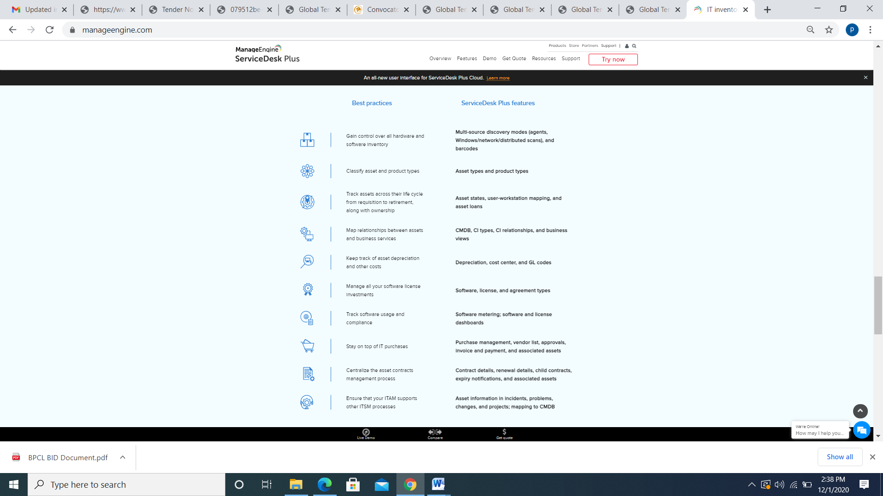

## Measure and improve your asset management operations

* + Hardware summary
  + Software summary
  + Audit history by workstation
  + Audit history by timeline
  + Audit history by changes
  + Total number of loaned assets
  + Prohibited software installations
  + Rarely used software installations
  + Computers by OS
  + Total number of active contracts
  + Assets depreciated by 50 percent or below
  + Assets by product type
  + Assets by vendor
  + Assets by site

ALERT FEATURES - Support alerts on any observed Hardware variance, Software variance in the system and shall notify respective administrator or manager via email alert. Like RAM is changed., Provide support for alerting on asset thresholds for asset stores: Alerts are triggered when there is a violation in the defined thresholds, Provide contract management support for purchase, lease, rental, warranty, rate, master, blanket and user defined contracts with Alerting by Mail, Sends alerts when an unauthorized software installation is detected, ensuring software compliance on an on-going basis, Capable of sending Notification to end User on Allocation of Assets and Online Acknowledgement of assets from End Users

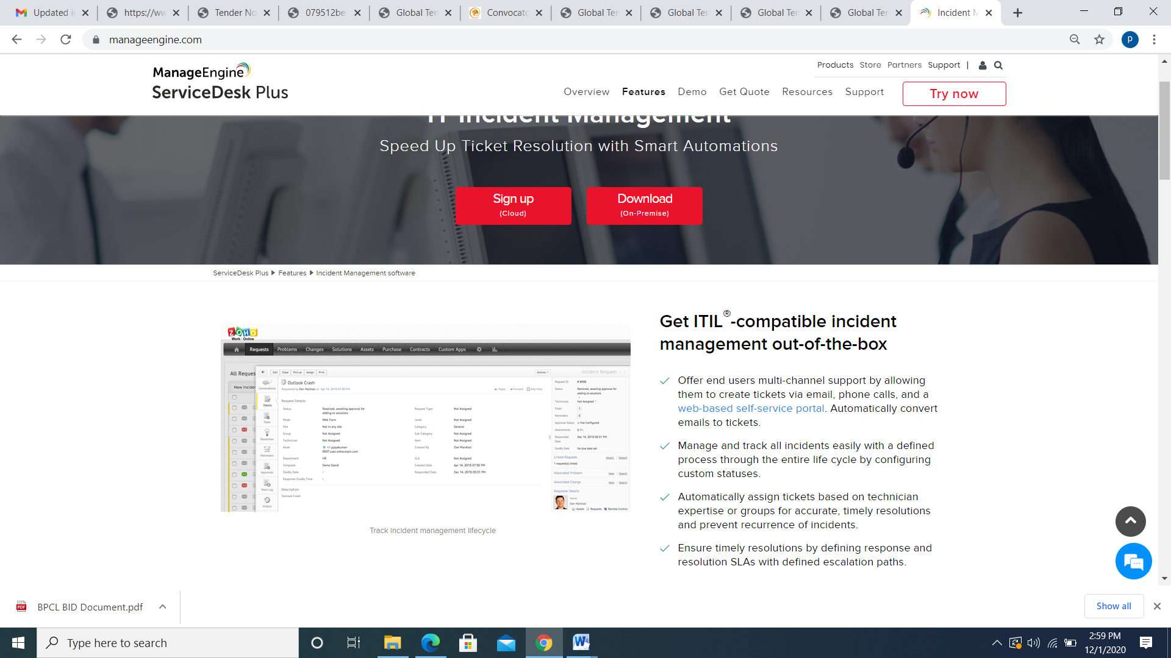

The offered product capable to generate Reports on parameters - IP address, Location, Purchase order wise, Hardware variance, Software variance, Software compliance report, Software license report, Operating system, Warranty /AMC, Patch Inventory Report, OS Deployment, Software Metering

## Benefits of Hardware Asset Management

### Gain end-to-end IT asset visibility

Normalize discovered hardware to maintain a clean CMDB and keep your asset inventory accurate.

### Accelerate asset workflows

Simplify lifecycle processes with automated asset workflows—request, receive, deploy, swap, and dispose.

### Reduce asset costs and risk

Get insights you can use to refresh strategic assets, minimize waste, and enable compliance.

REPORT FEATURES - Provides hardware inventory reports about workstations in the Organization’s infrastructure such as OS details, CPU details, network information, hard disk details, and RAM slots etc.,Provide software inventory report details about software installed in workstations across the network,The solution shall have Advance reporting capability to create or generate report/dashboards based on chosen parameters/fields and generate adhoc reports based on the needs of the Organization,Capable to provide dashboard of graphical representation as well as tabular form of all the assets based on category, location, aging of the asset

DASHBOARD FEATURES - Customized Dashboard for each Admin role

Software Asset Management dashboard

View true-up costs, optimization results, and compliance trend charts on the Software Asset Management dashboard.

The Software Asset Management dashboard tab is accessed by navigating to **Software Asset** > **Overview** and selecting **Software Asset Management** from the dashboard list. Click an element within a report to see more information, or add and move widgets as needed.

Results are updated daily, or whenever a new reconciliation result is available, and can be refreshed by clicking the **Refresh** icon for each result. You can also save charts in PNG or JPG formats.

The graphs show important statistics about the software being tracked. In the Overview and Optimization tabs, you can filter by publisher, product, department, and country to narrow the results.

Overview

The source for overview data is the Product Result [samp_product_result] table.

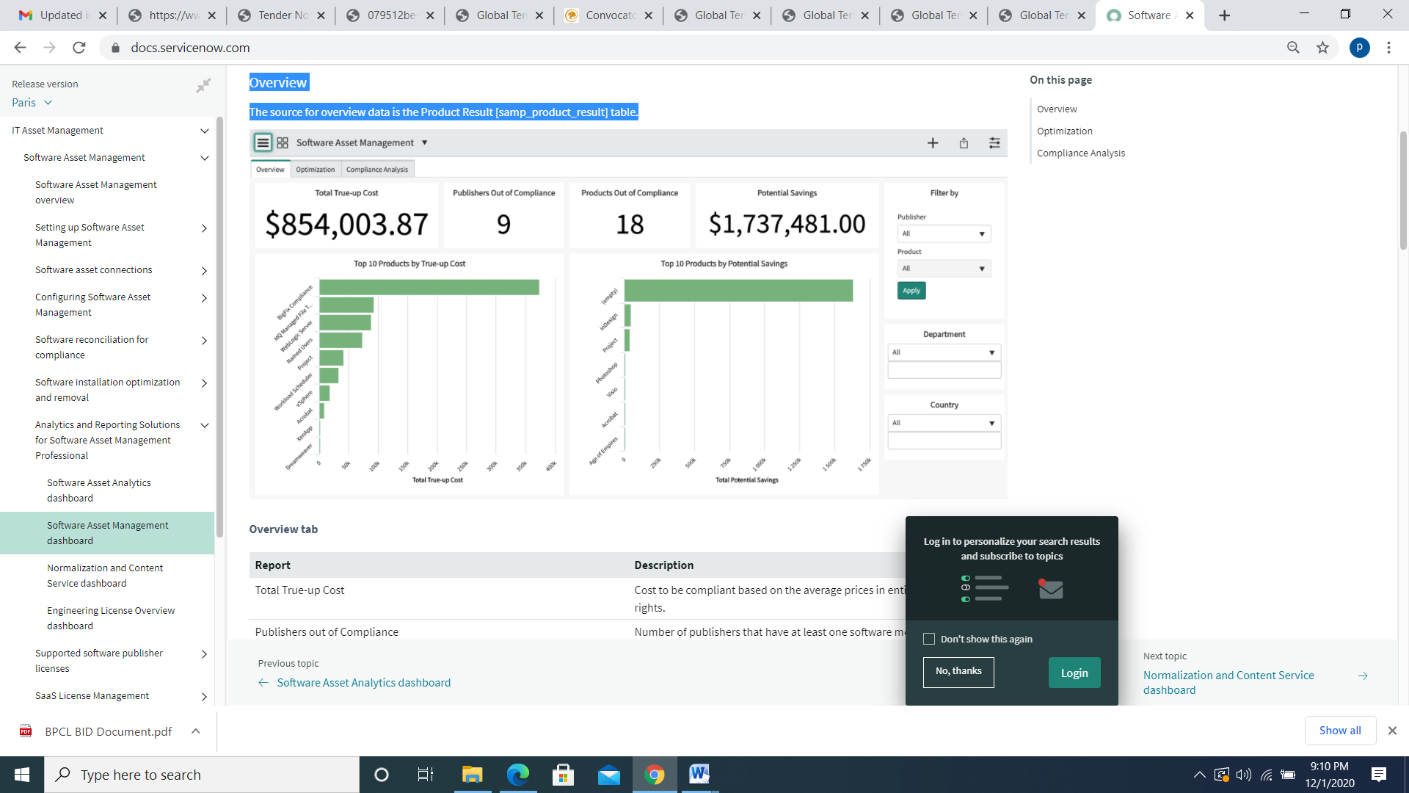

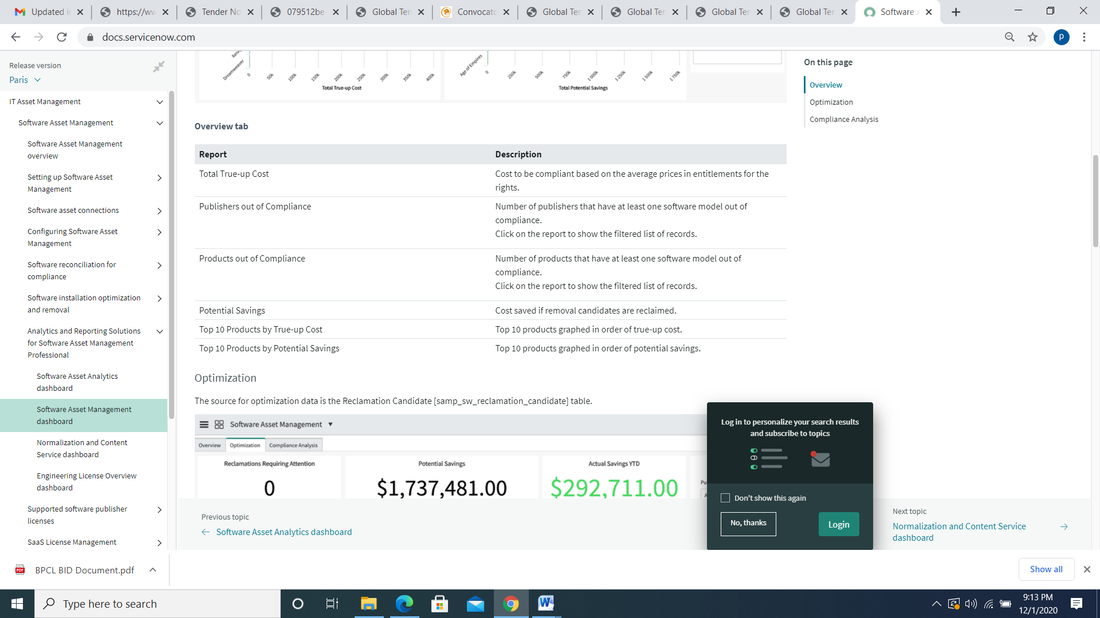

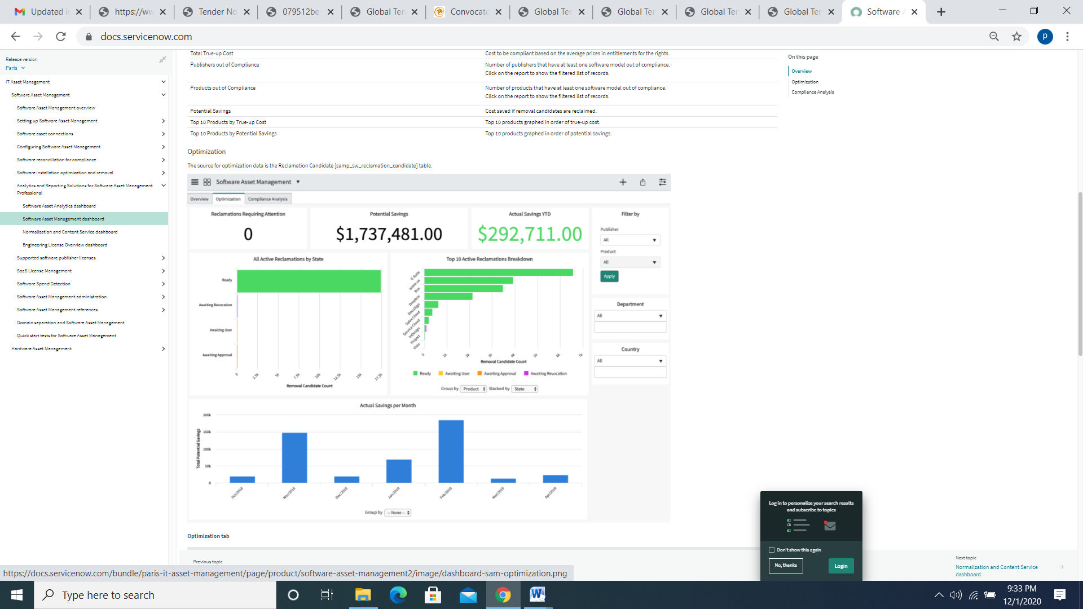

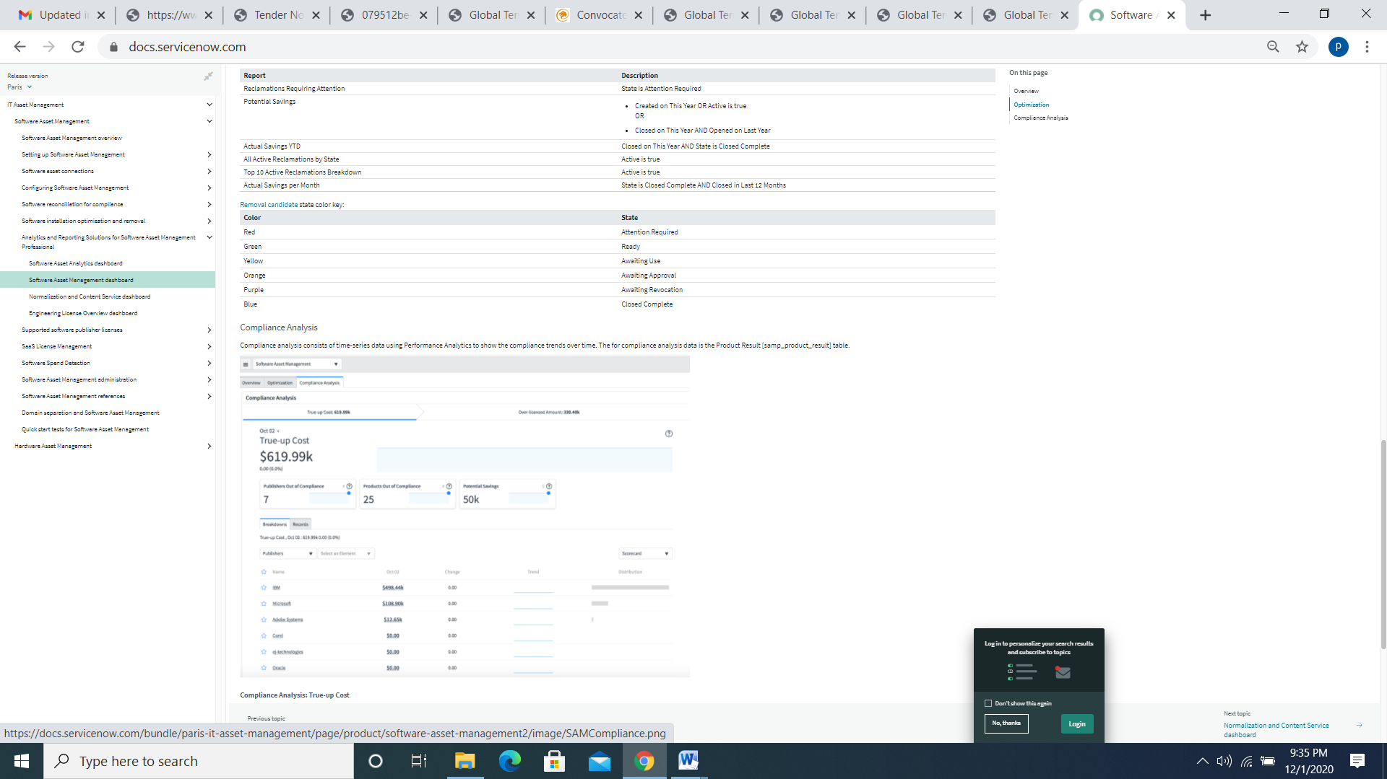

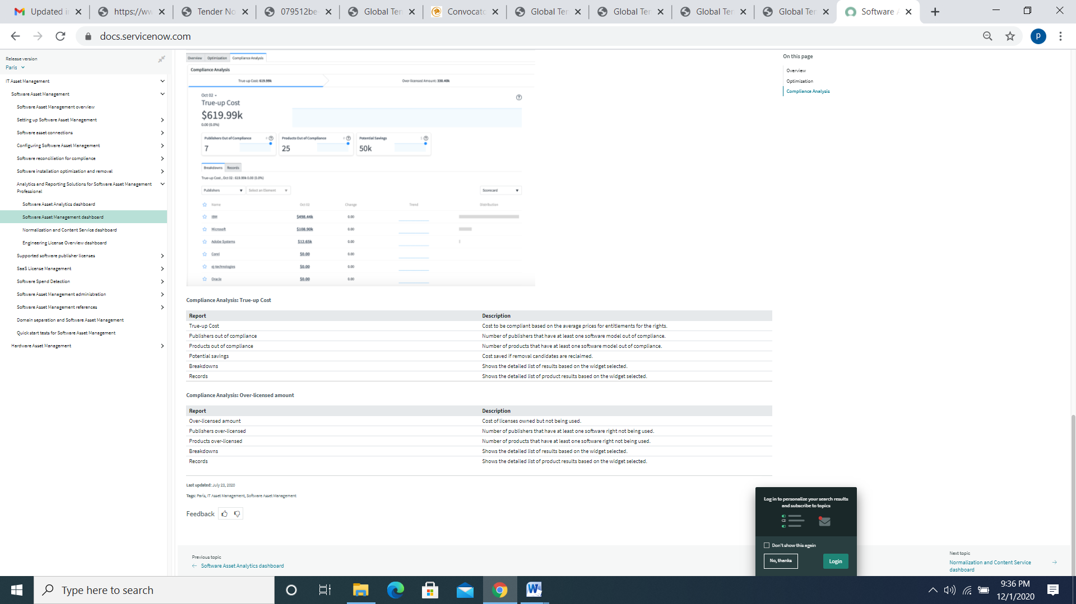

GENERIC FEATURES - HelpDesk Tool Integrations, Browser Management, Power Management, HelpDesk Tool Integrations, Remote Control Administration, Remote Session Recordings, System tools & configurations, Third Part Software Updates & Upgrades, GUI Based management interface, VM support

Helpdesk Management System,

At **DigitoWork** IT Help desk acts as the single point of contact (SPOC) for your users to request Information Technology (IT) related support. Whether the users are within your organization or from outside, our Help Desk support software will help sort, categorize and manage all these issues from one single intuitive interface.

**DigitoWork** combines the best of IT help desk and IT service desk - catering to every IT management scenario and giving you complete control over an issue’s lifecycle.

### Track IT Incidents and Outages with an Efficient Ticketing System

* **DigitoWork** tickets can be grouped into different categories like Incident management, outages or Service Requests.
* Get support requests from multiple channels - Email, Phone, API, Ticket Forms, Chat, etc.
* **DigitoWork** makes it easy to customize your service desk to the needs of your business workflows, using custom fields, priorities, and statuses.

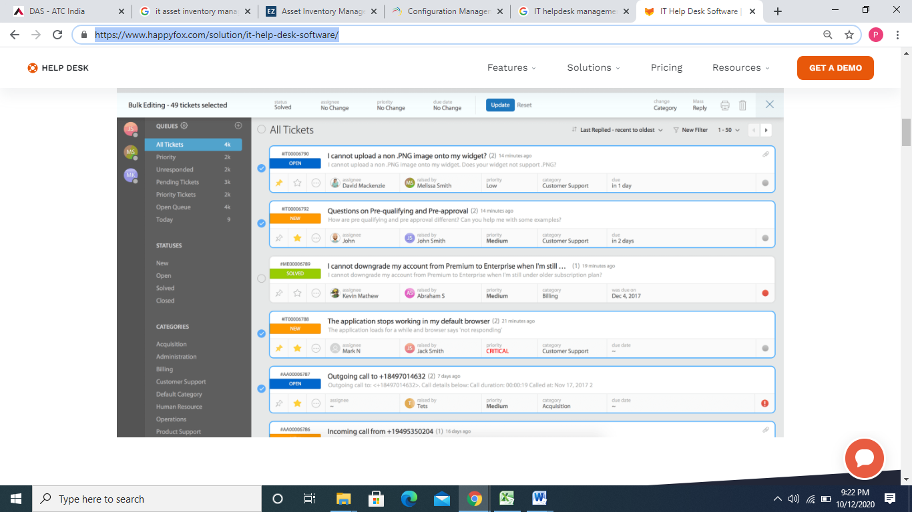

### Make informed Decisions with Real-time Help Desk Reporting

Monitor Ticket Inflow through various channels, Identify peak hours and tweak agent availability.

Report on high-level View high-level performance metrics like FCR % (First call resolution), Time to closure, Response times, etc. and drill down by ticketing properties.

Boost your IT support team’s performance using Insights from the Agent Activity Report . Quantify Ticket Participation and identify top performers.

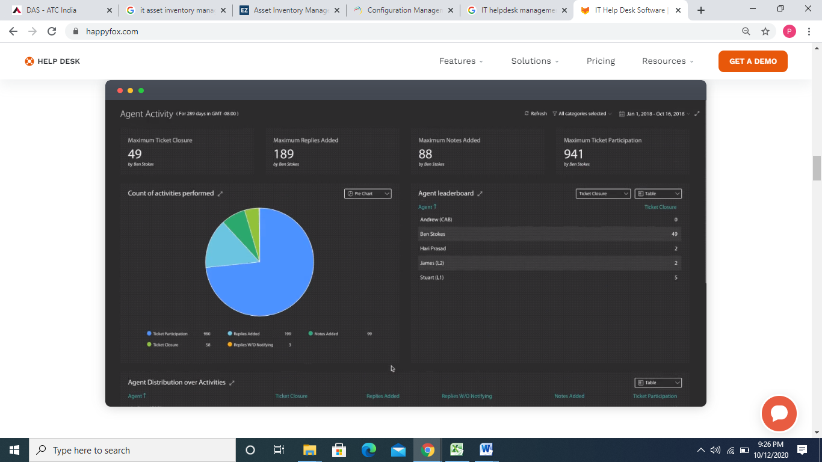

Manage Help desk Performance and 3rd party Relationships with Service Level Agreements (SLAs)

* Measure, Monitor & Report your SLAs.
* RAlerts and Escalations to help ensure timely resolution of issues/requests.
* Define business hours across time zones and regions depending on your help desk staff availability and enforce SLAs only when your agents work.



### Benefits of using an IT Help Desk Software

* Using a customer service platform to support your IT help desk operations can bring numerous benefits.

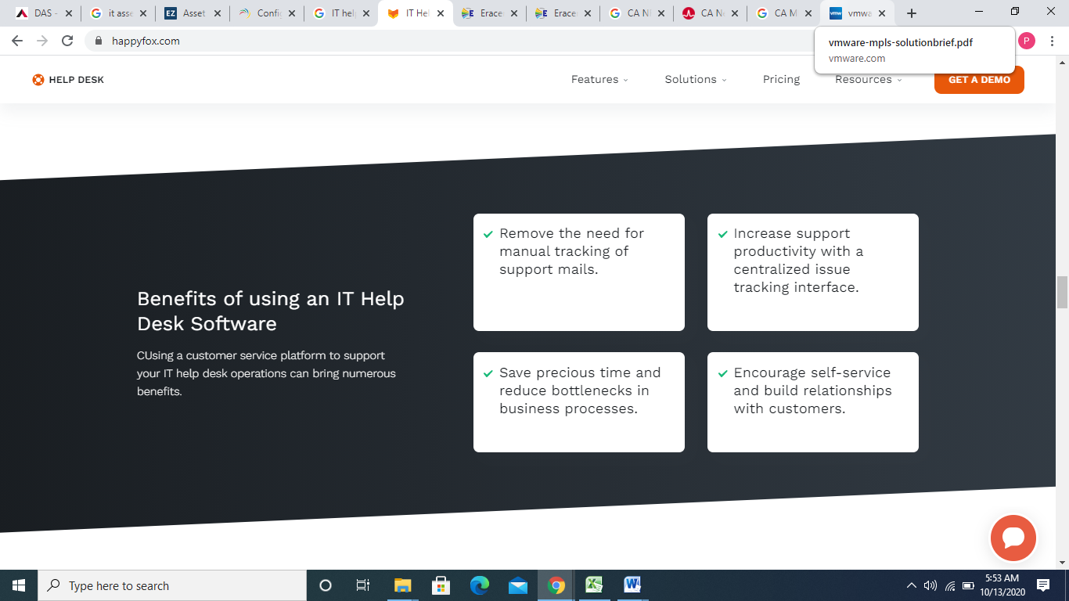

Enable Clients/Employees to Self-Serve themselves

* Create a repository of FAQs and Knowledge base articles for repetitive end-user requests/inquiries.
* Build a beautiful, branded, Mobile Responsive IT Support Center using a no-code drag and drop builder.
* Reduce your incoming ticket inflow through intelligent ticket deflection.

Put Your Repetitive Support Workflows on Autopilot

* Auto-assign tickets to the right agents through intelligent auto-assignment algorithms.
* Set up powerful automation rules with conditional logic to solve complex technical support scenarios.
* Audit Logs and intuitive automation builder (Smart Rules) makes automating help desk functions fast and easy.

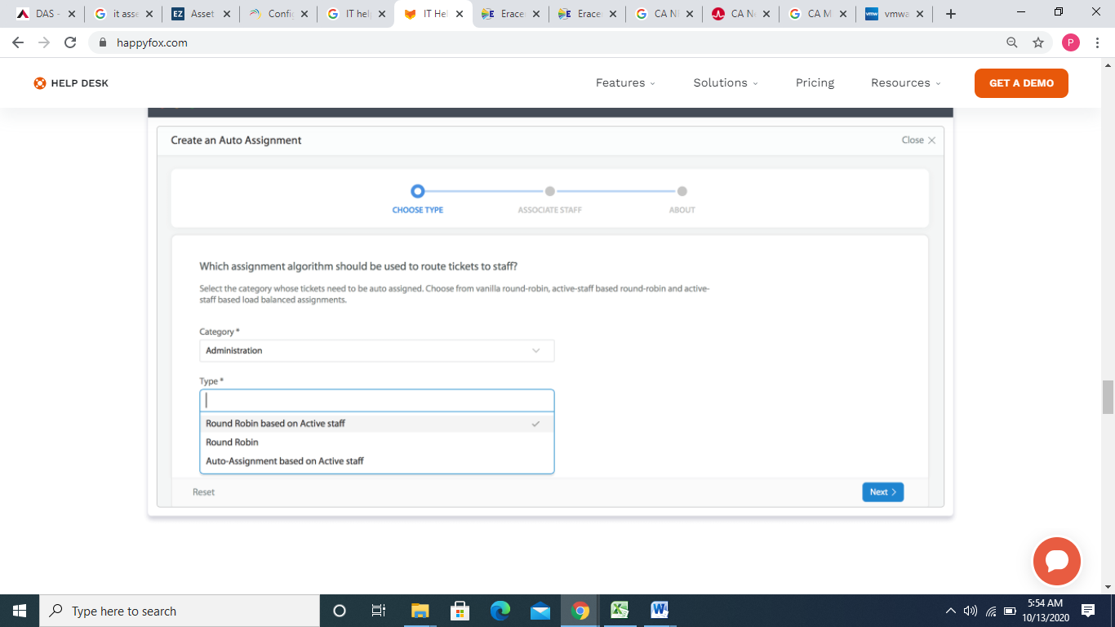

### Streamline Workflows and Productivity with Integrations

* Link support tickets and [JIRA](https://www.happyfox.com/help-desk-integration/help-desk-issue-tracking/) issues to double up as a bug tracking system.
* Provide exemplary remote customer support with [LogMeIn](https://www.happyfox.com/help-desk-integration/remote-help-desk-support-logmein/) Rescue Integration.
* Synchronize issue comments and ticket replies between **DigitoWork.** and [GitHub](https://www.happyfox.com/help-desk-integration/github-issue-tracking/) and improve Developer & Support collaboration.

### Track and Manage Software and Hardware Assets in one place

* Manage asset requests by searching for existing assets and linking them to a ticket.
* See complete info about assets within the tickets, and make informed decisions.
* Import all your existing Software and Hardware assets into **DigitoWork.**

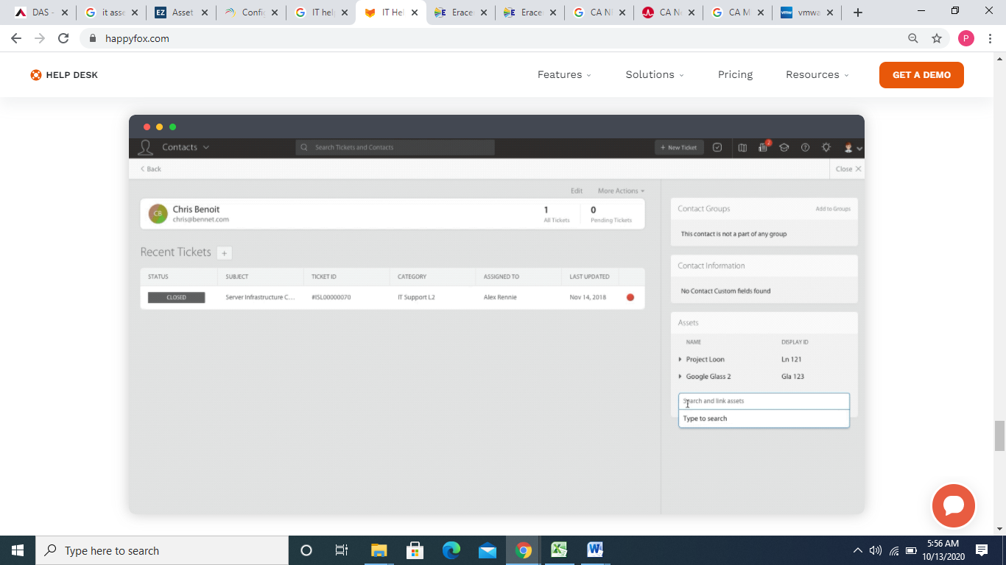

Incident Management- Incident Management restores normal service operation while minimizing impact to business operations and maintaining quality.

ServiceNow Incident Management supports the incident management process in the following ways:

* + Log incidents in the instance or by sending email.
  + Classify incidents by impact and urgency to prioritize work.
  + Assign to appropriate groups for quick resolution.
  + Escalate as necessary for further investigation.
  + Resolve the incident and notify the user who logged it.
  + Use reports to monitor, track, and analyze service levels and improvement.
  + Any user can record an incident and track it through the entire incident life cycle until service is restored and the issue is resolved.

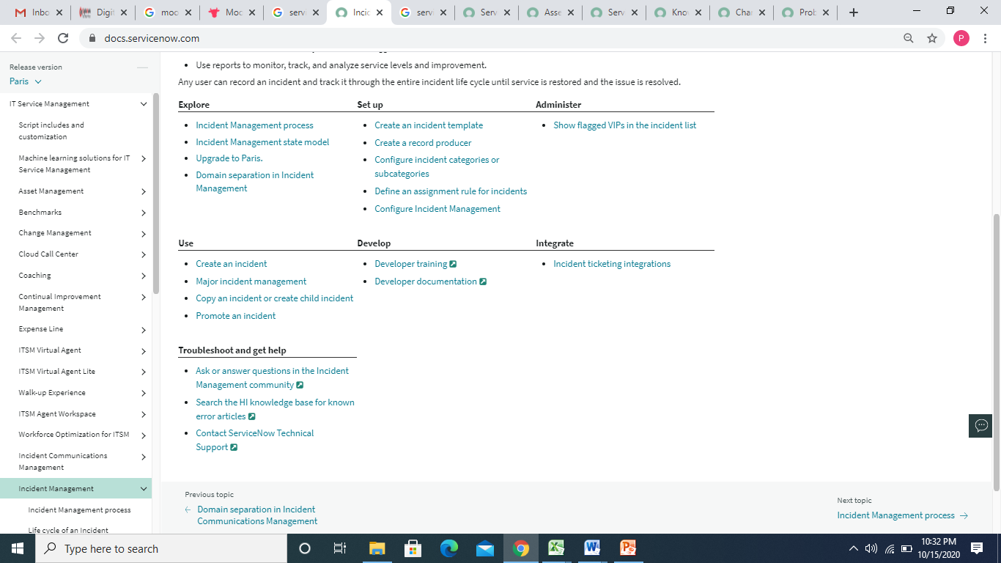

2. Problem Management- Problem Management helps to identify the cause of an error in the IT infrastructure, reported as occurrences of related incidents. Problem Management is responsible for managing the life cycle of all problems and to prevent problems and resulting incidents from happening. It also aims at eliminating recurring incidents and minimizing the impact of incidents that cannot be prevented. Resolving a problem includes the activities required to diagnose the root cause of incidents and to determine the resolution for the problem. Problem resolution and elimination of root cause often calls for applying a change to the configuration item in the existing IT environment.

Problem Management also maintains information about problems and the appropriate workarounds and resolutions, so that the organization is able to reduce the number and impact of incidents over time. In this respect, Problem Management has a strong interface with Knowledge Management so that the known error articles are documented thoroughly for any future reference.

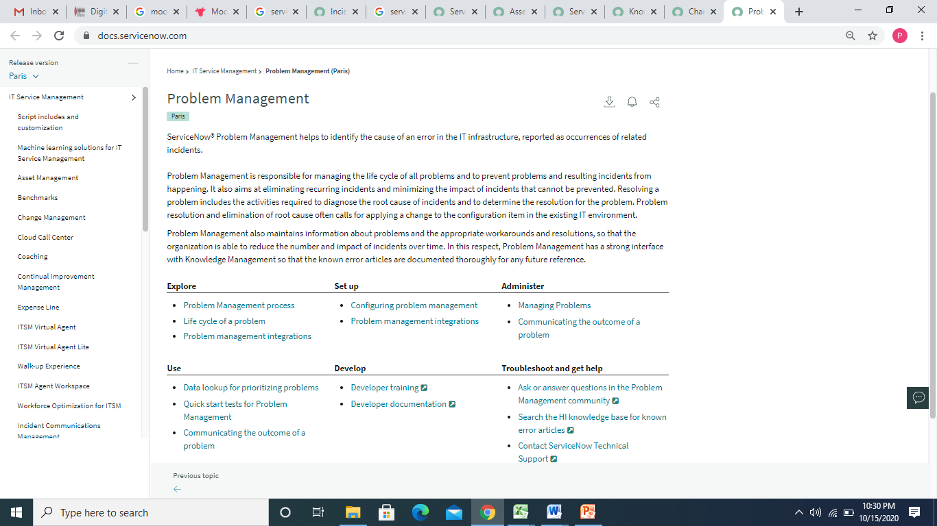

3. Change Management- Change Management application provides a systematic approach to control the life cycle of all changes, facilitating beneficial changes to be made with minimum disruption to IT services.

Change Management integrates with the Vulnerability response plugin to introduce extra functionality within Change Management.

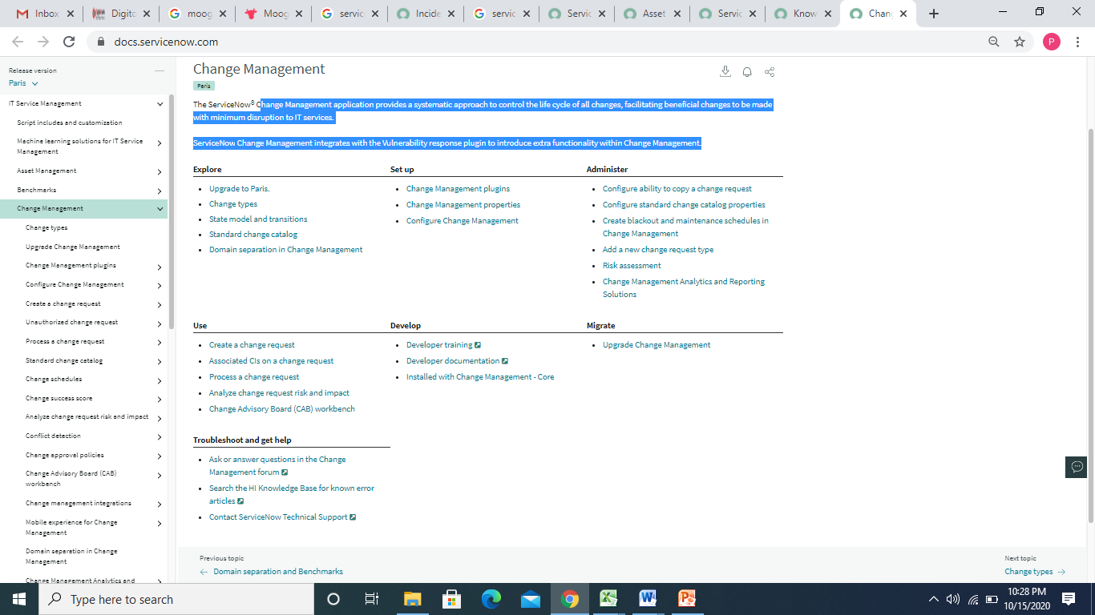

4. Knowledge Management- Knowledge Management (KM) application enables the sharing of information in knowledge bases. These knowledge bases contain articles that provide users with information such as self-help, troubleshooting, and task resolution. Knowledge Management has significantly changed with Knowledge v3, which is enabled by default for all instances starting with the Fuji release.

The Knowledge Management Service Portal enables users to access a portal view of knowledge bases and articles. It is available by default for new customers on the Madrid and later releases. If required, existing and upgrade customers can activate the Knowledge Management Service Portal plugin.

Knowledge Management supports processes for creating, categorizing, reviewing, and approving articles. Users can search and browse articles as well as provide feedback.

To support multiple groups, knowledge bases can be assigned to individual managers. Separate workflows can be used for publishing and retiring articles, and separate access controls can be used to control reading and contributing.

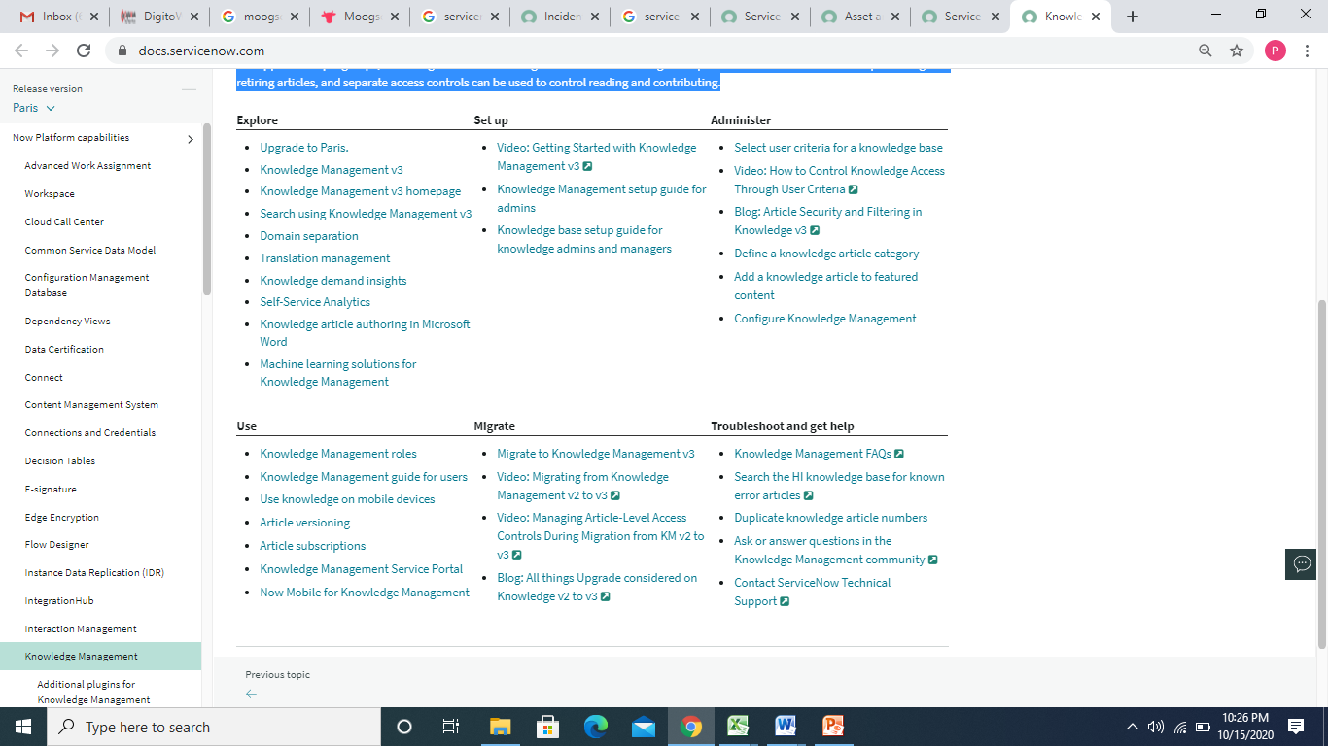

5. Service Level Management- Service Level Management (SLM) application helps to gather service requirements as well as monitor and report with regards to agreed service levels (SLAs). SLM can be used across the organization in departments such as HR, Facilities, and IT. Service Level Managers are responsible for negotiating a set of agreements between a service provider and customer that define the scope, quality and speed of the services being provided and ensuring that the agreed service levels are met.

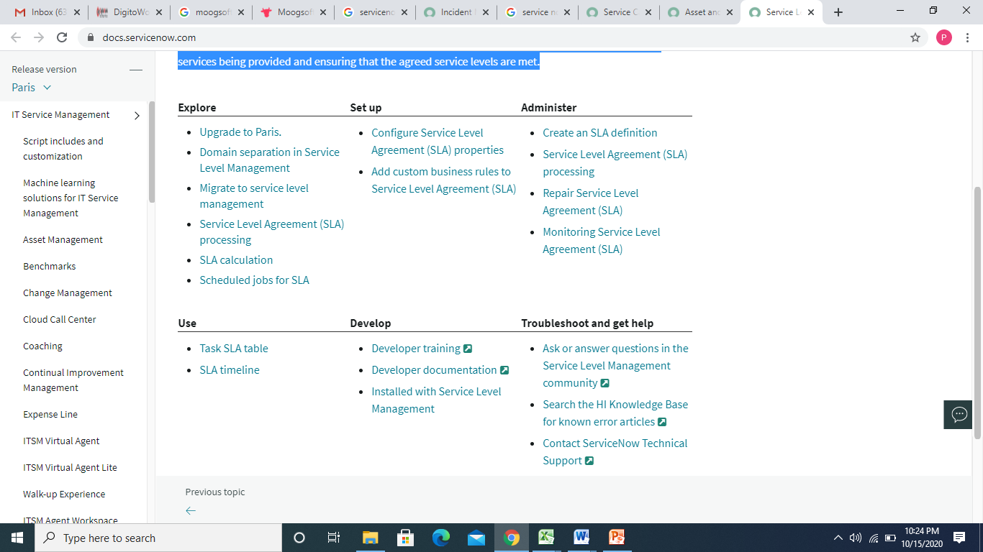

6. Service Asset and Configuration management- Asset and configuration item (CI) management refers to creating assets, setting appropriate states and substates, synchronizing assets and CIs, managing consumables, and retiring assets.

## Relationship between asset and CI

It is important to manage the relationship between assets and associated CIs. Assets are tracked with the Asset Management application, which focuses on the financial aspects of owning property. Configuration items are stored in the CMDB, which is used to track items and make them available to users.

When an asset has a corresponding configuration item, the asset record and the configuration item record are kept synchronized with two business rules.

* **Update CI fields on change** (on the Asset [alm_asset] table)
* **Update Asset fields on change** (on the Configuration Item [cmdb_ci] table)

**Note:** Assets and CIs can be synchronized only if they are logically mapped.

## Asset-CI mapping and synchronization

The State field of asset record and Status field of CI record are synchronized so that changes made on one form trigger the same update on the corresponding form, ensuring consistent reporting.

**Note:** The Now Platform synchronizes updates between assets and configuration items only if the asset and configuration item are pointed toward each other.

The following diagram illustrates the concept of Asset-CI mapping and synchronization.

**Asset-CI mapping and synchronization: An Overview**

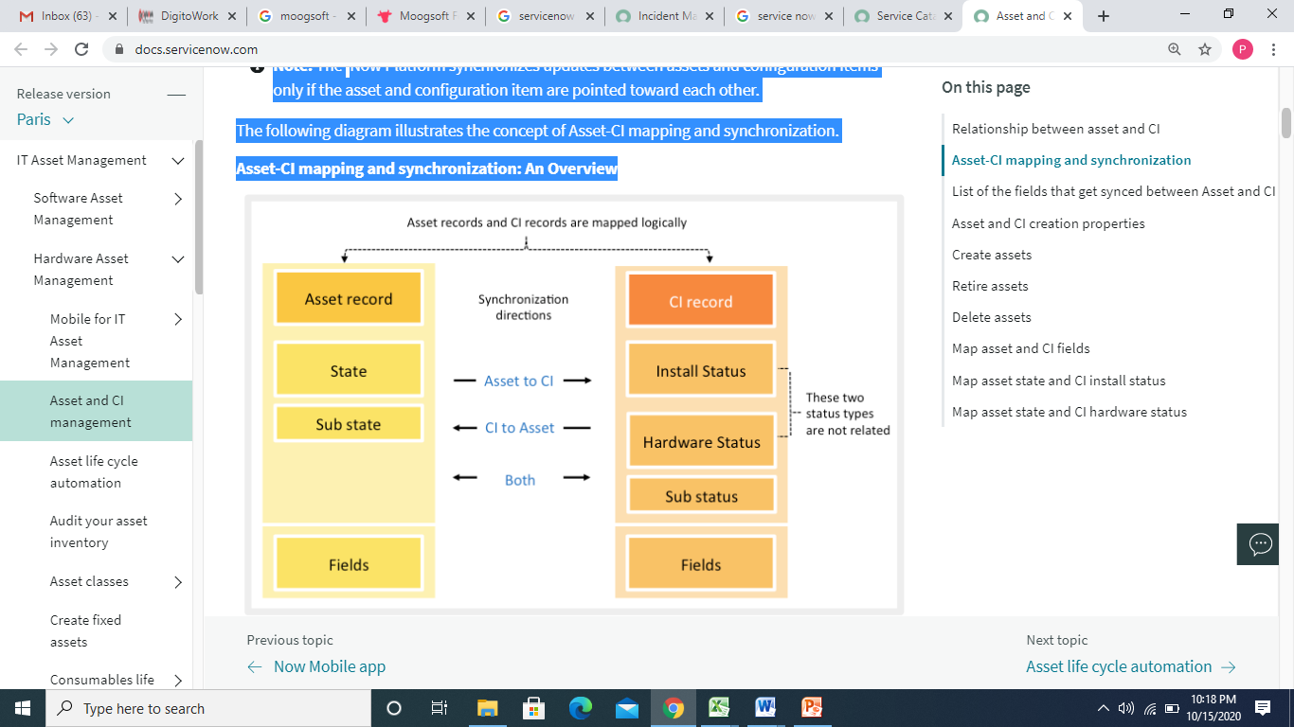

This synchronization and mapping is based on the following factors:

* Asset state and CI status are not mapped on one-to-one basis; rather they are mapped to the most logical counterpart on the other table. For example, for a hardware asset set to state **In Stock - Pending disposal**, the corresponding CI is set to **In Disposition** with no substate.
* This synchronization happens between the asset’s State field and the following CI fields:

Install Status field: Install Status does not have a sub status and must be used for non-hardware CIs.

* Hardware Status and Sub status field: Hardware Status is visible only for Hardware CI.

Drive changes by updating the state on the Asset form. The Asset-CI synchronization can be driven in the following ways:

* Asset to CI synchronization: Change to the asset’s status updates the logically mapped CI’s Install Status or Hardware Status and sub status.
* CI to Asset: Change to the CI’s activate Status or Hardware Status updates the logically mapped asset’s states and sub states.
* For a CMDB hardware CI, if both Hardware Status and Install Status is updated, the Hardware Status change is considered for mapping the corresponding state of the asset.
* CI’s Install Status and Hardware Status work independently, so the two fields aren't related. CI’s Hardware Status change does not change CI’s Install Status and vice versa. To avoid confusion, keeping both status for CMDB CI Hardware is not recommended.

## List of the fields that get synced between Asset and CI

When modifying any of following fields on the asset or CI record, the same field on the corresponding record is automatically updated (with the exception of the **Cost** field, which is informational-only on the CI record).

Following is a list of fields that are synched.

* Asset tag
* Assigned
* Assigned to
* Checked in
* Checked out
* Company
* Cost (synchs in only one direction: asset to CI)
* Cost center
* Delivery date
* Department
* Due in
* Due
* GL account
* Install date
* Invoice number
* Justification
* Lease id
* Location
* Managed by
* Model
* Order date
* Order received
* Ordered
* Owned by
* PO number
* Purchase date
* Purchased
* Serial number
* Support group
* Supported by
* Vendor
* Warranty expiration

Create assets

You can create hardware, Serialized Hardware and Non-Serialized Hardware Assets, software license, consumable, license, and software entitlement.

HARDWARE / SOFTWARE REQUIREMENTS AT BUYER END

Backend Operating System required by the offered product - Windows, Windows Mobile/ Phone, Mac, Android, Linux, iO S

**IT Asset Management**

Map your physical, virtual and cloud networks automatically with automated asset inventory discovery tool.

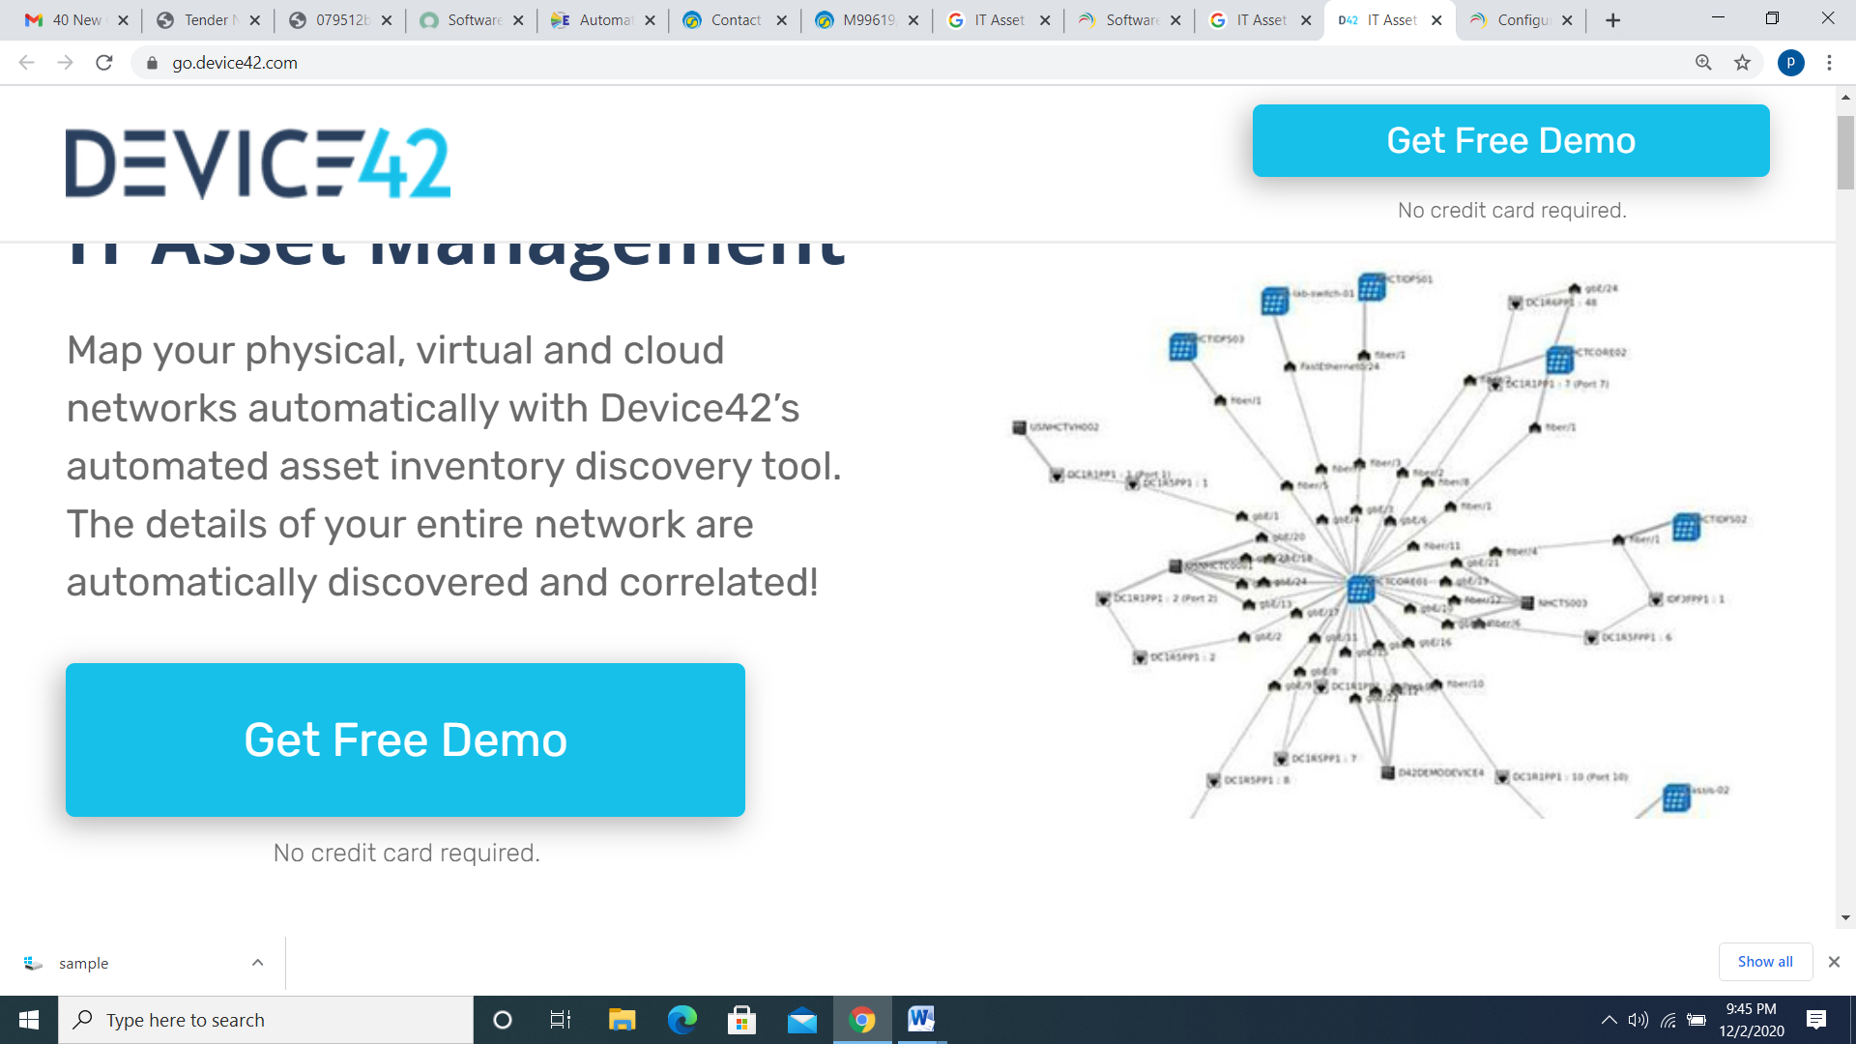

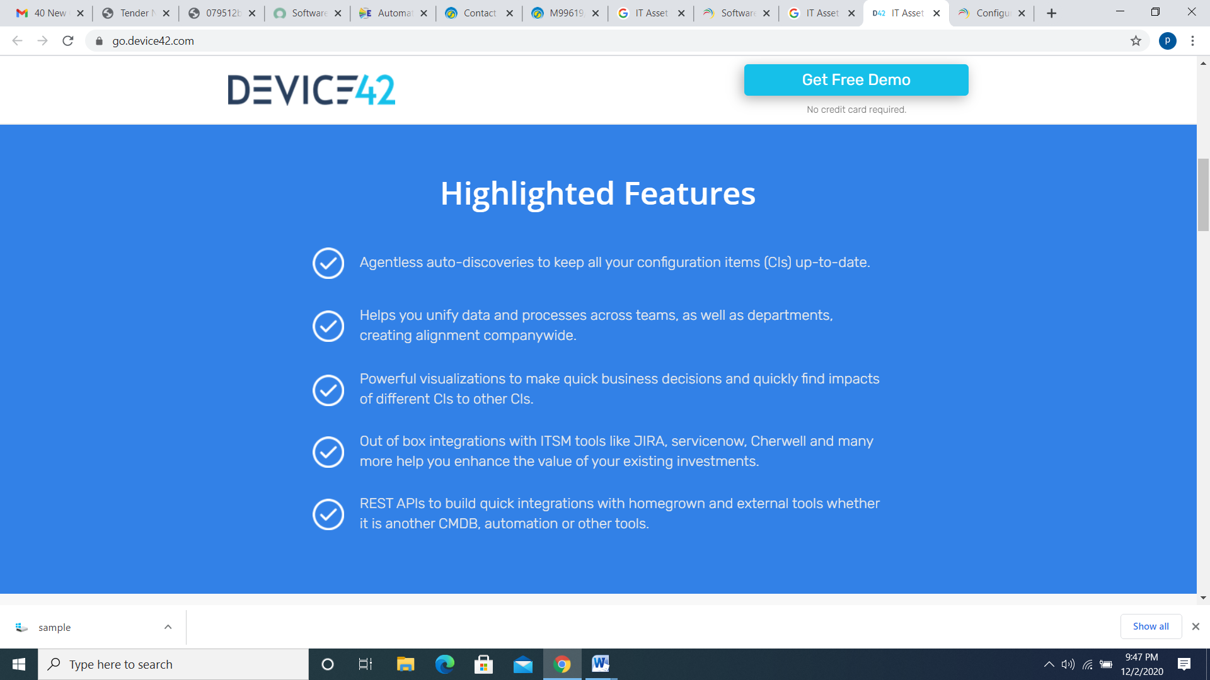

Backend Web browsers required by the offered product - Internet Explorer, Google Chrome, Mozilla Firefox

# Configuring Browser Settings

### Table of contents

1. General settings
2. Proxy
3. Restrictions
4. Security settings
5. Advanced settings

You can choose to configure browser settings for computers using Desktop Central. Securing browsers is one of the essential ways of securing corporate data. Desktop Central supports the following browsers on Windows operating system:

* Google Chrome
* Microsoft Edge
* Firefox
* Internet Explorer

Backend database required by the offered product – MSSQL

**DigitoWork** extends support for using MS SQL Server database for storing the configuration and data. This document will explain the steps,

* 1. To configure MS SQL Server as the back-end database.
  2. To set up a fresh MS SQL Server database or migrate data from an existing database to new MS SQL Server database.

### Hardware Requirements for SQL Server

The hardware requirements for SQL server include the following:

|  |  |  |  |
| --- | --- | --- | --- |
| **No. of Computers/Devices Managed** | **Processor Information** | **RAM Size** | **Hard Disk Space** |
| 1 to 5000 | Intel Core i7 (6 core/12 thread) 3.2 GHz. 12 MB cache | 8 GB | 200 GB* |
| 5001 to 10000 | Intel Xeon E5 (8 core/16 thread) 2.6 GHz. 20 MB cache | 16 GB | 250 GB* |
| 10001 to 15000 | Intel Xeon E5 (12 core/24 thread) 2.7 GHz. 30 MB cache | 32 GB | 500 GB* |
| 15001 to 20000 | Intel Xeon E5 (14 core/28 thread) 2.7 GHz. 30 MB cache | 64 GB | 500 GB* |

­­

**DigitoWork** Value Proposition for BPCL

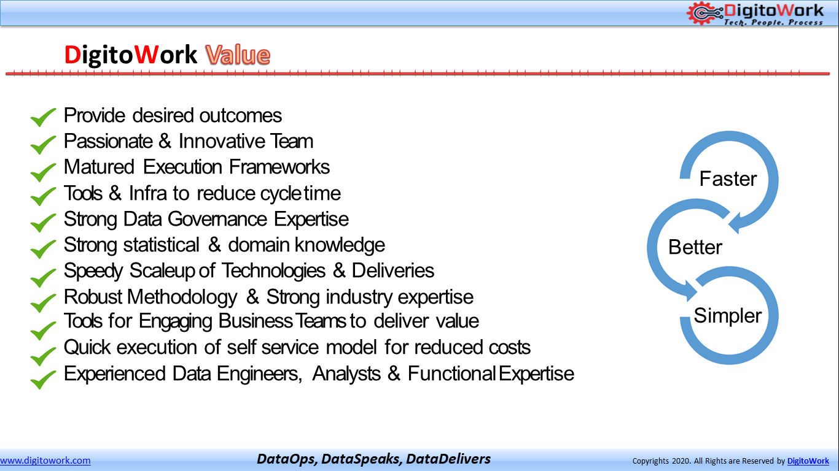

**Thank You**